Tour ID: 246354  
Tour Name: East Greenland Scoresby Sund Explorer Fly & Cruise - 12 Guests Only

Tour destinations: ['Reykjavik', 'Scoresby Sound']

Tour destinations images:

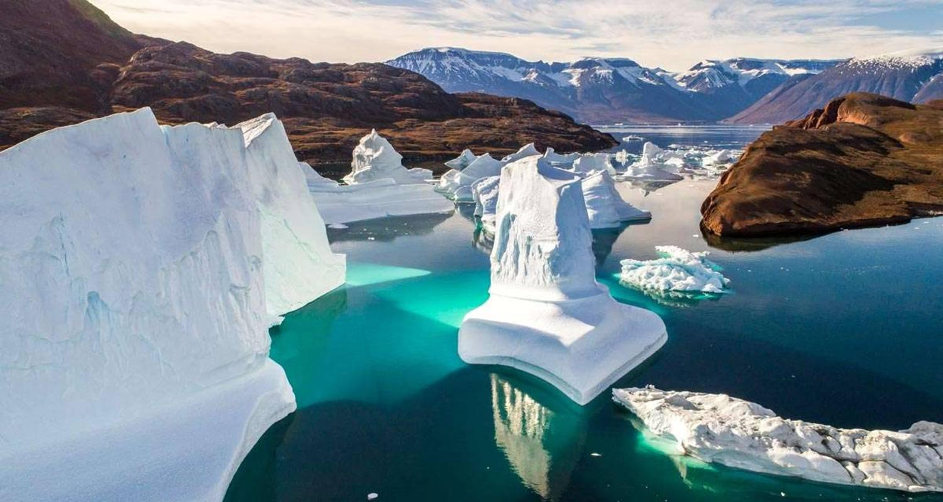

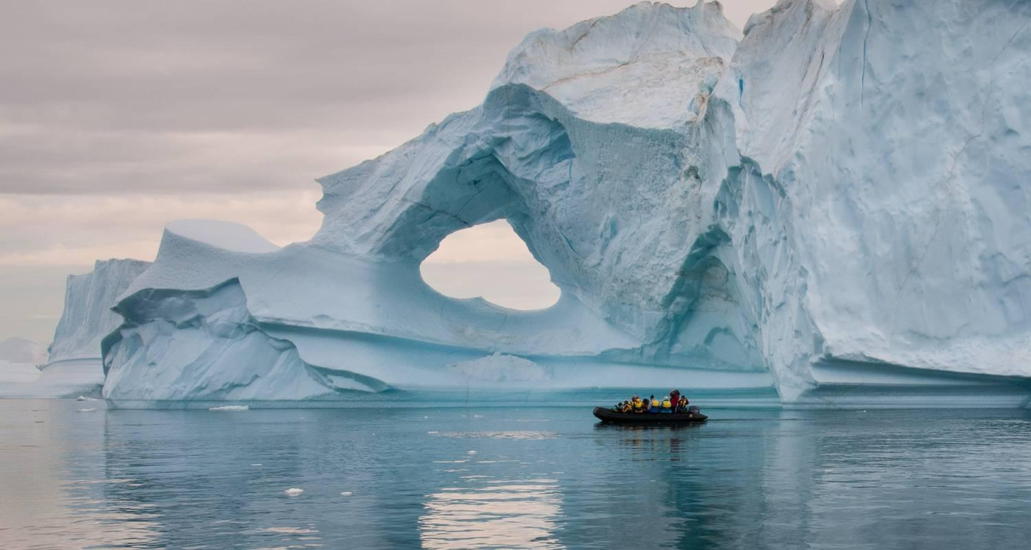

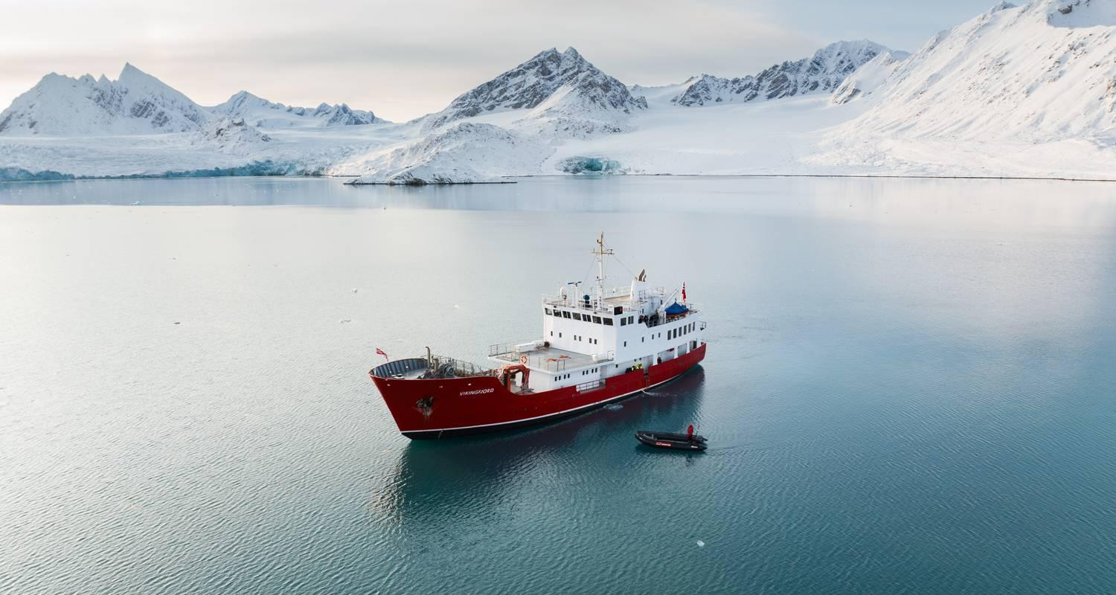

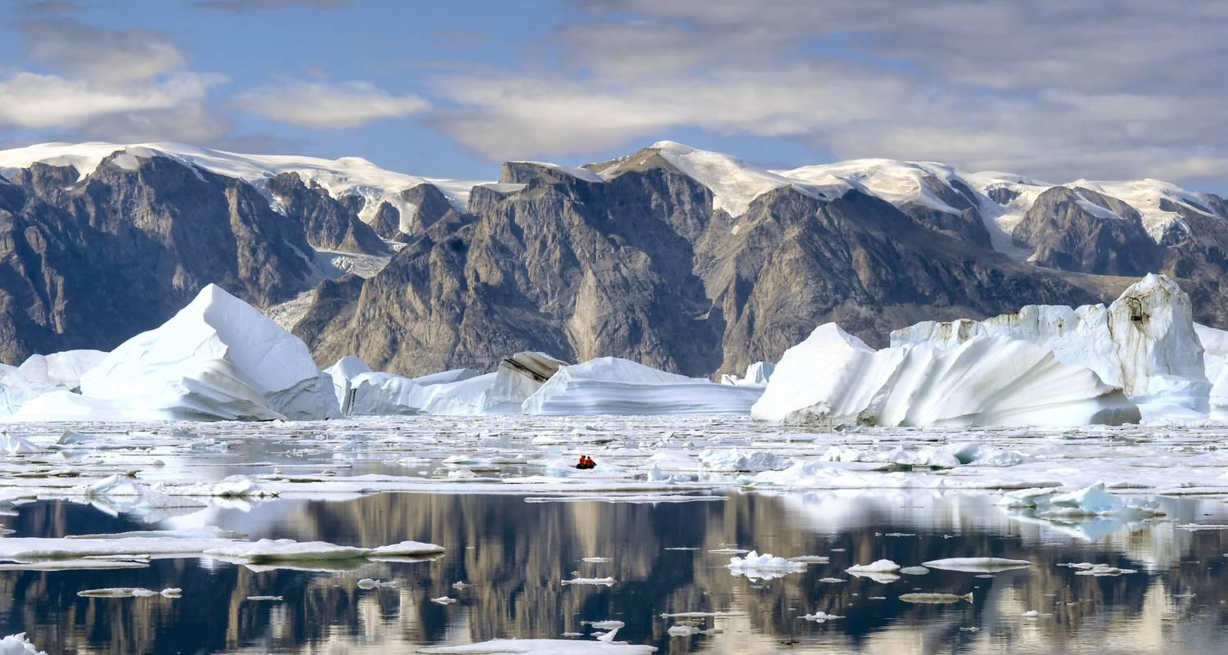

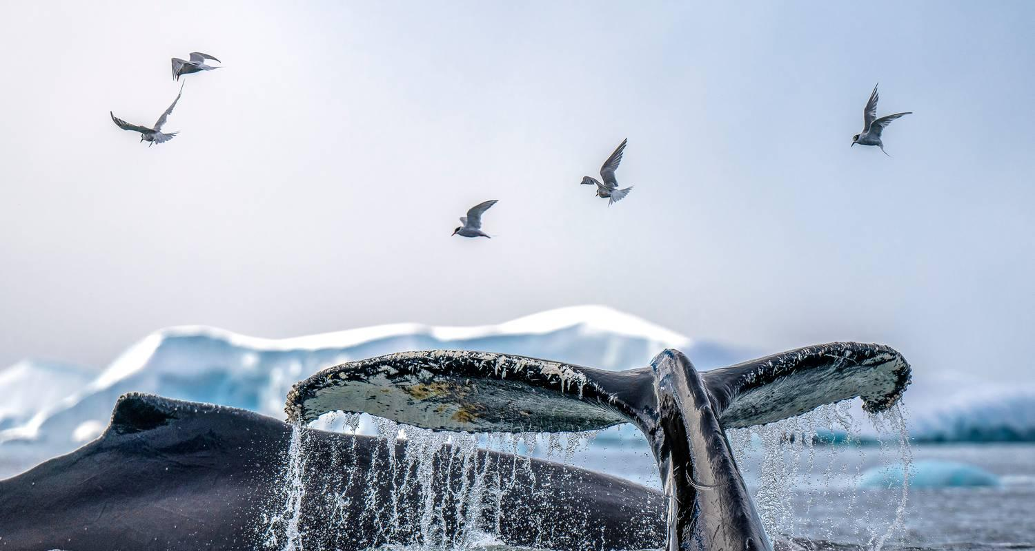

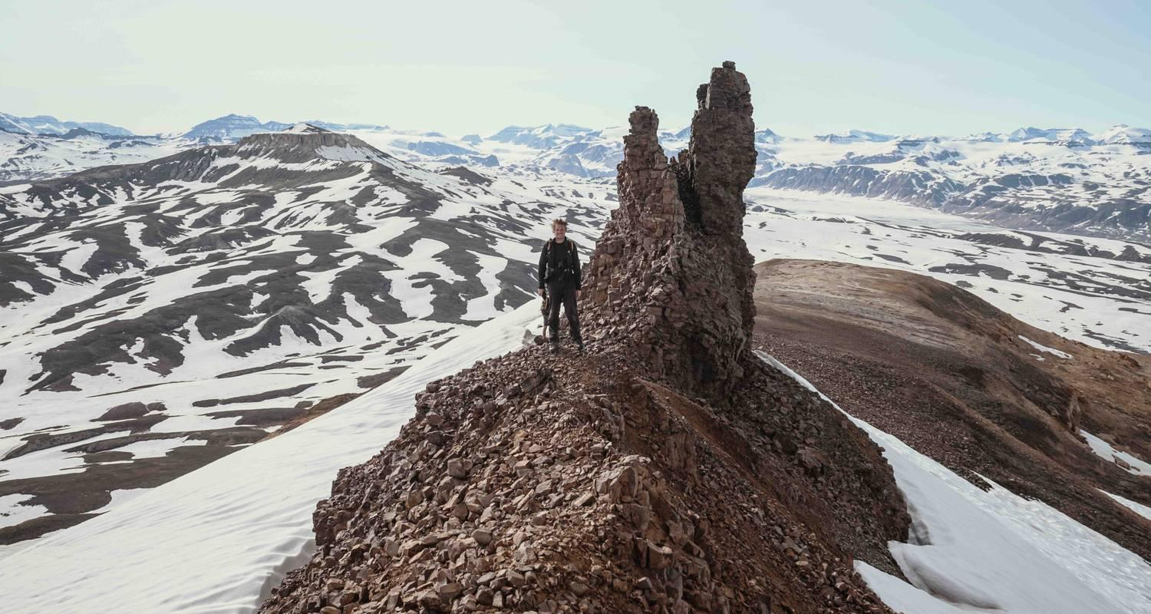

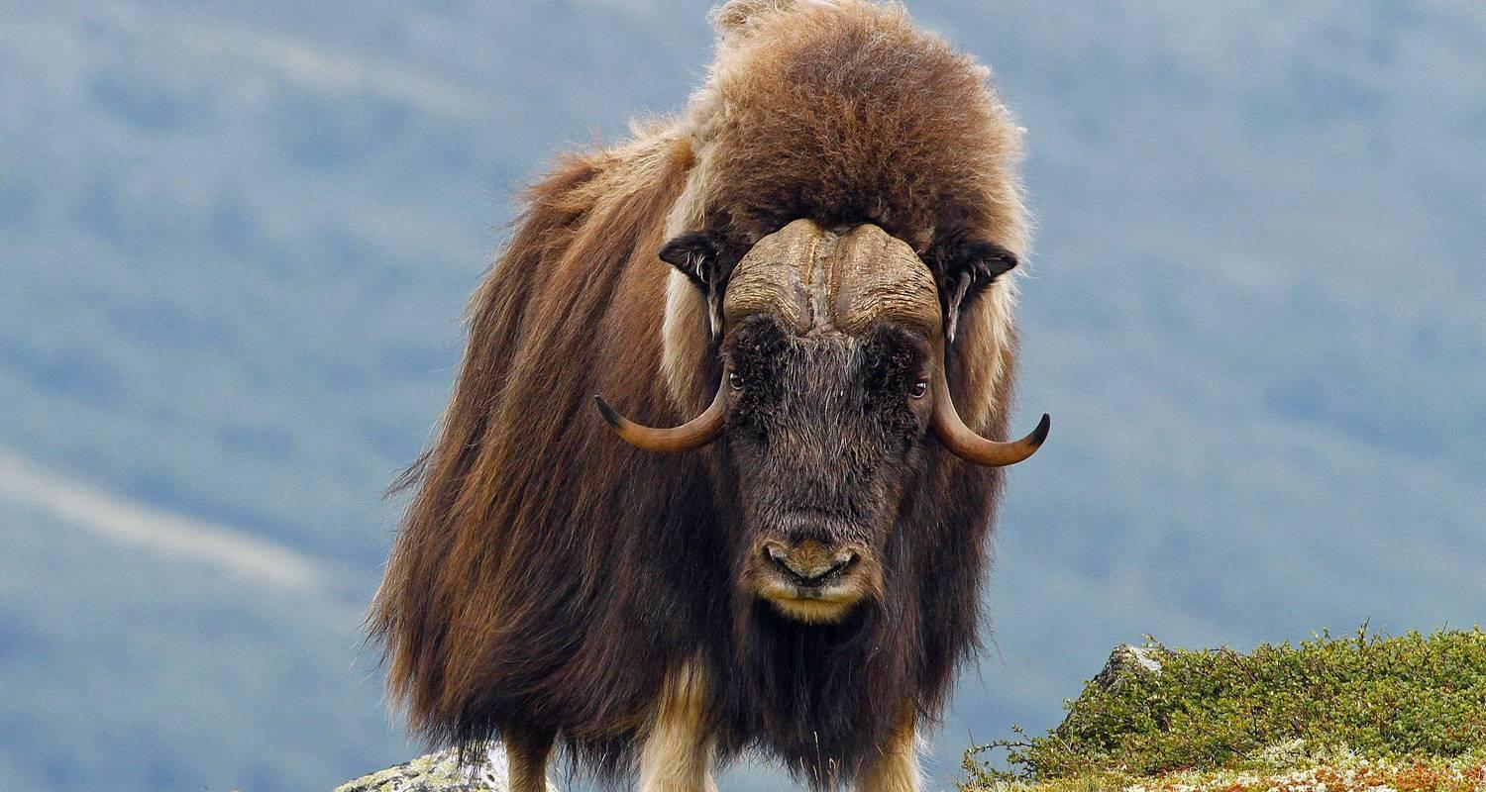

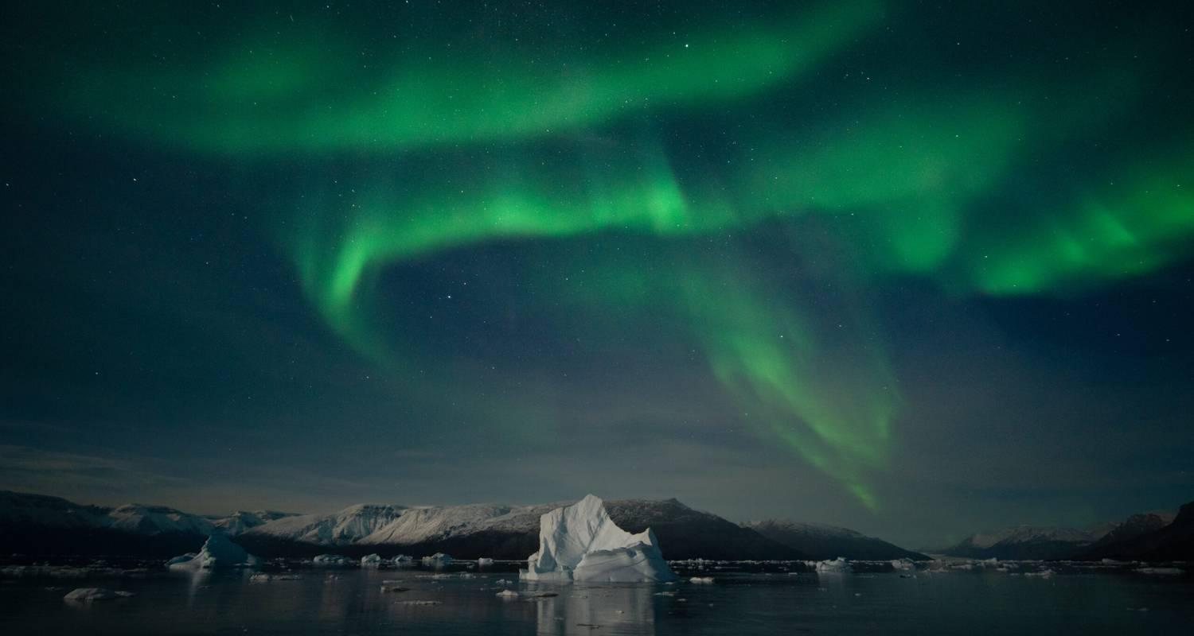

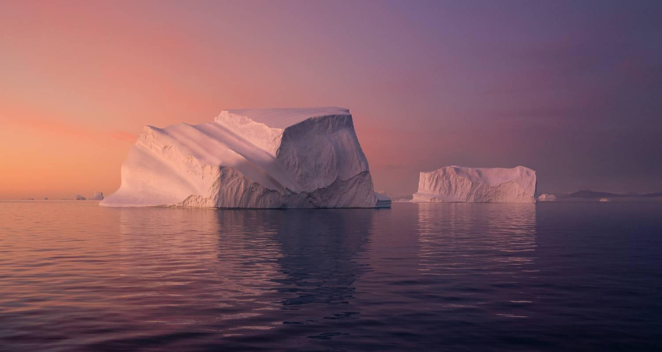

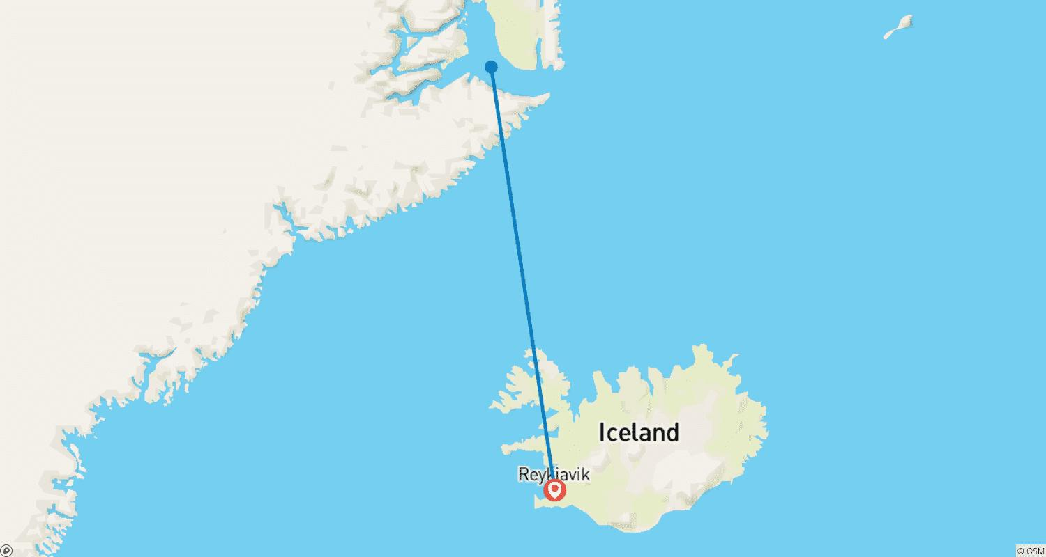

Tour ID: 246635  
Tour Name: Iceland Encompassed - 12 days

Tour destinations: ['Reykjavik', 'Gullfoss', 'Borgarnes', 'Snæfellsnes', 'Patreksfjordur', 'Hvammstangi', 'Laugarbakki', 'Akureyri', 'Bakkagerdi', 'Hofn', 'Vatnajokull National Park', 'Vik']

Tour destinations images:

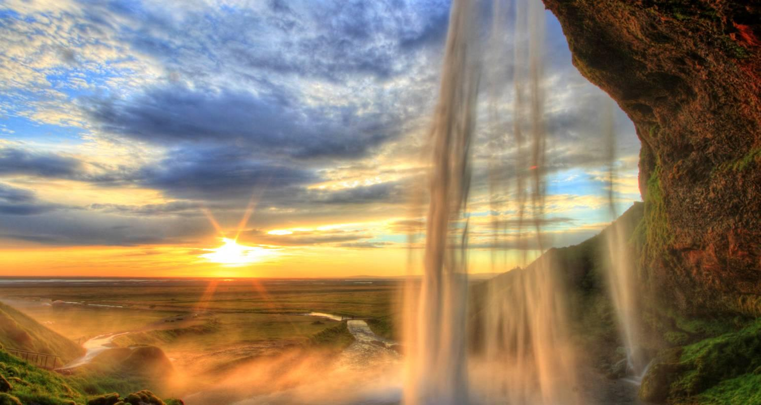

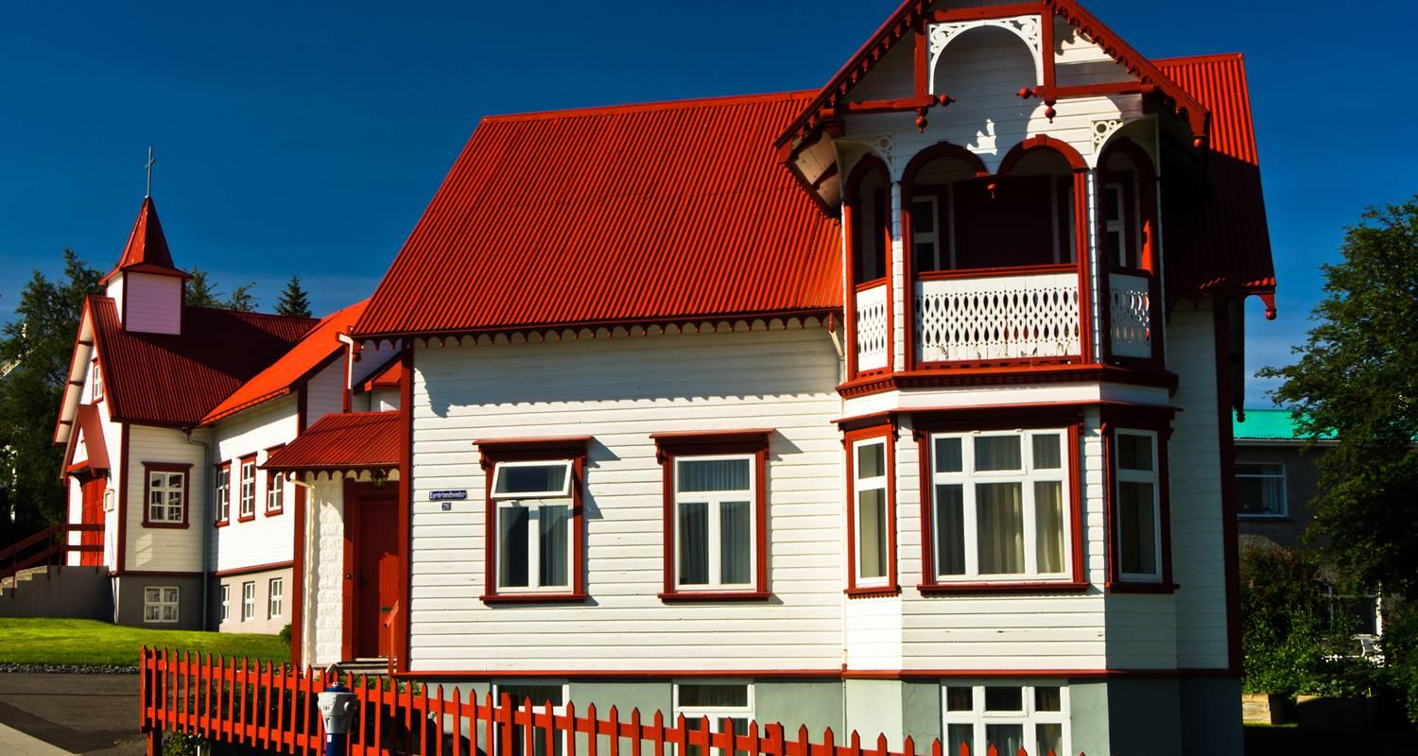

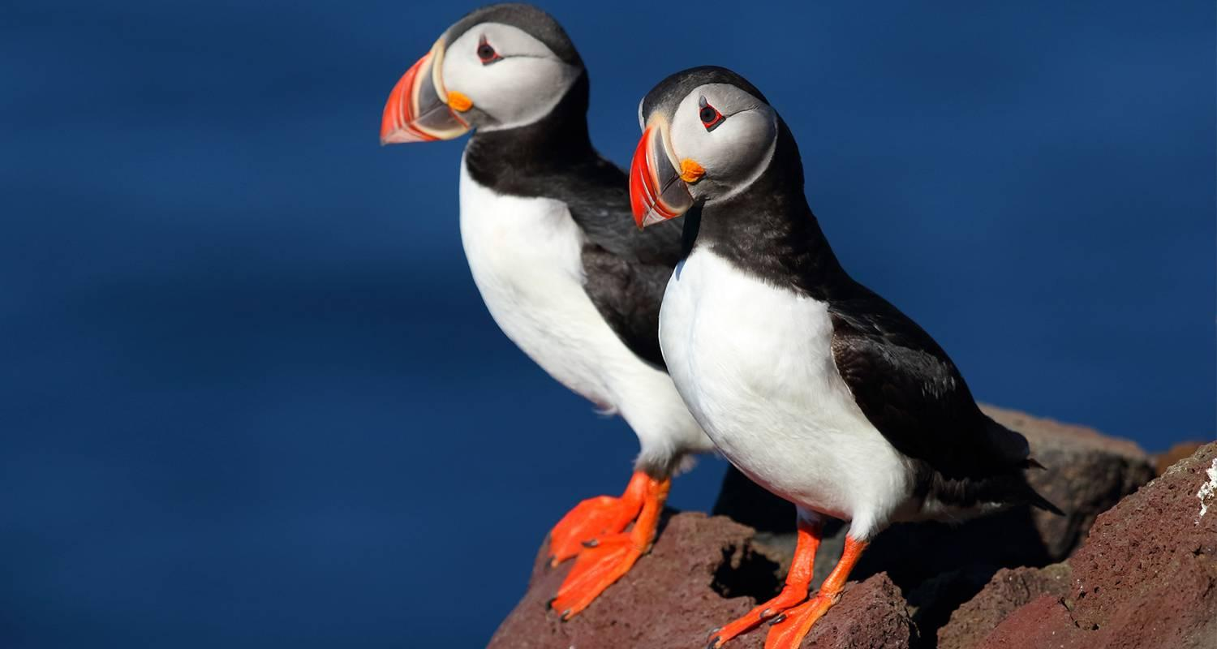

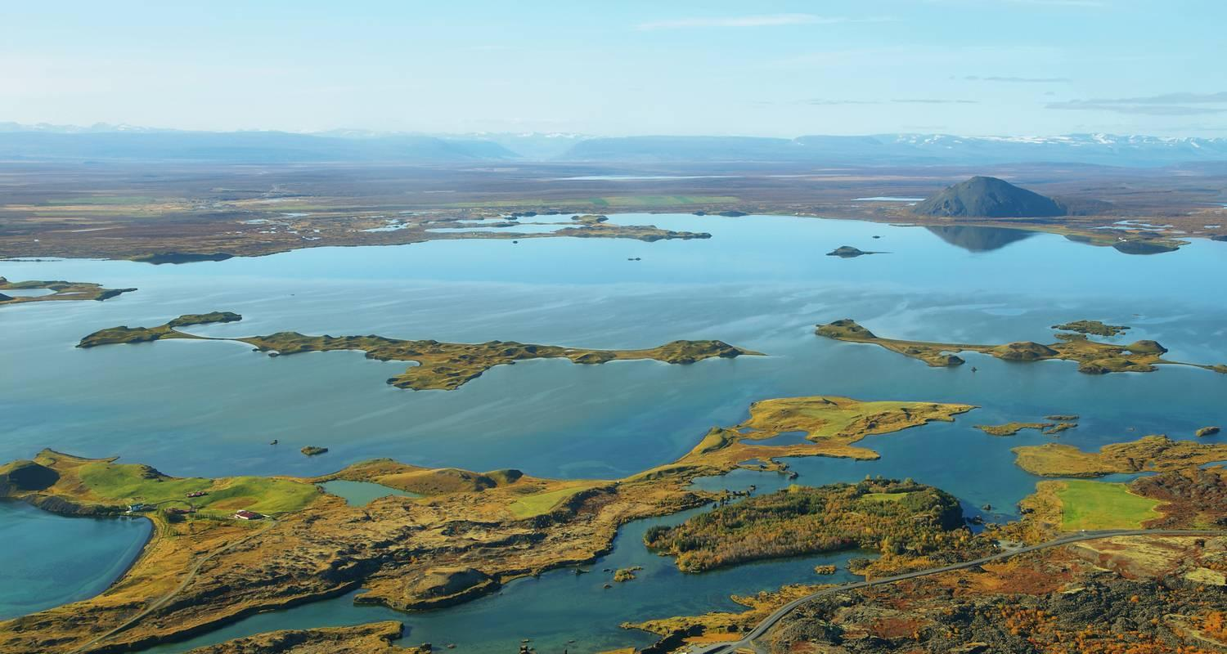

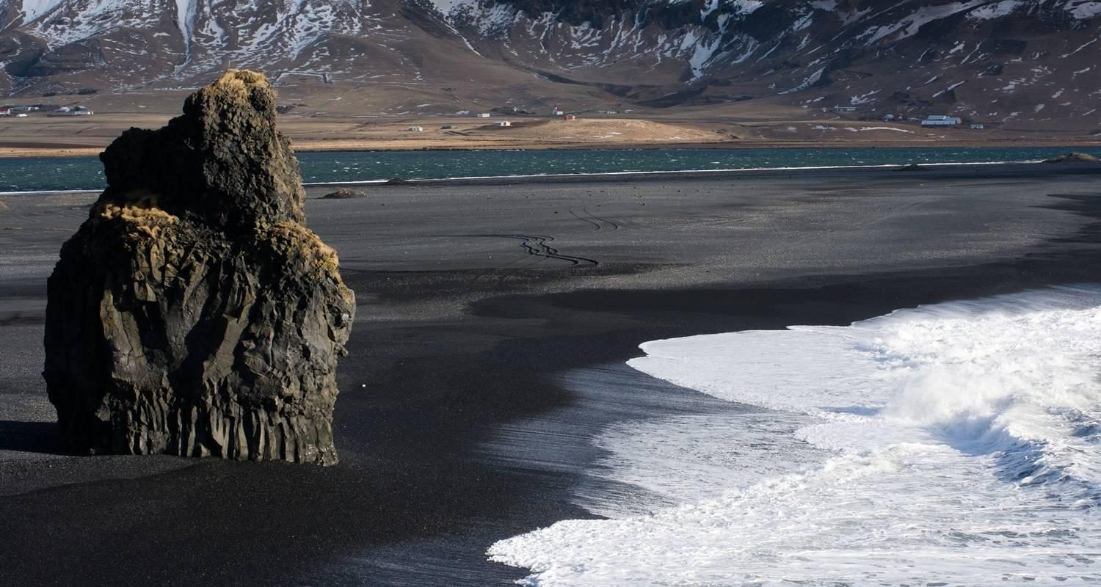

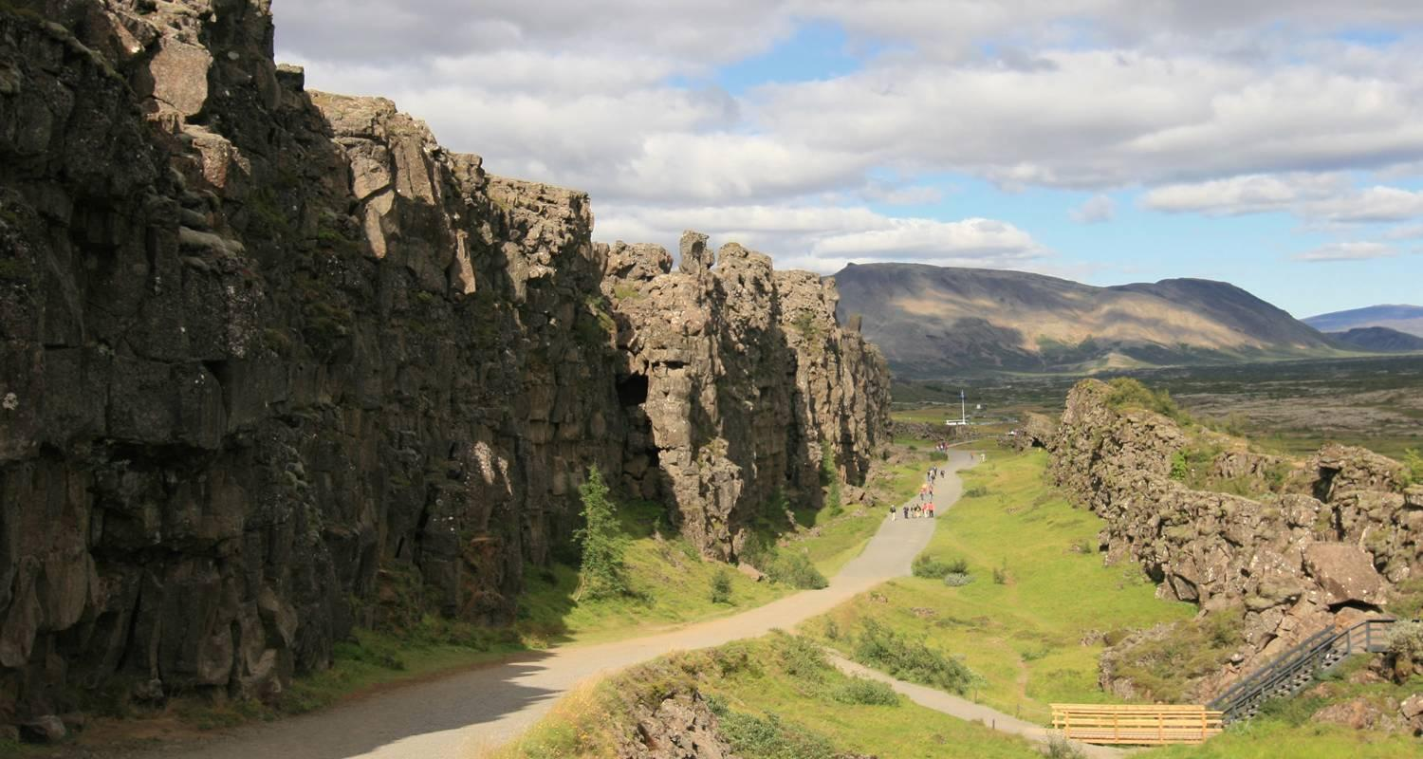

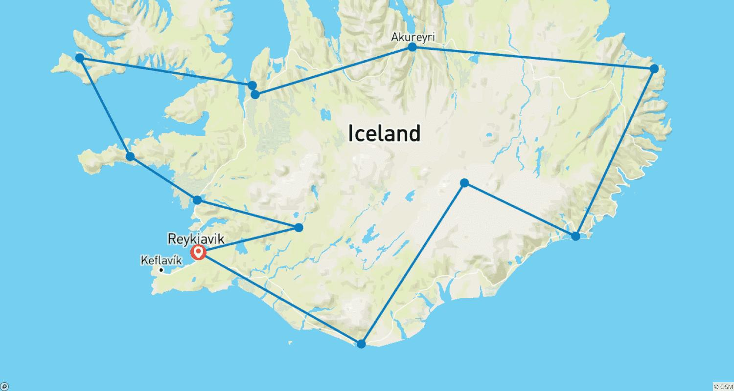

Tour ID: 247332  
Tour Name: Circumnavigating Iceland & Crossing the Arctic Circle

Tour destinations: ['Reykjavik', 'Flatey', 'Latrabjarg', 'Vigur', 'Saudarkrokur', 'Akureyri', 'Grimsey', 'Seydisfjordur', 'Surtsey']

Tour destinations images:

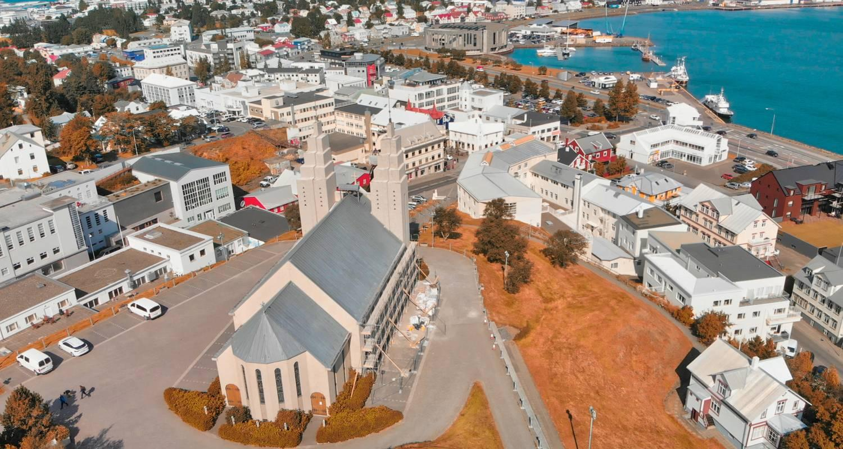

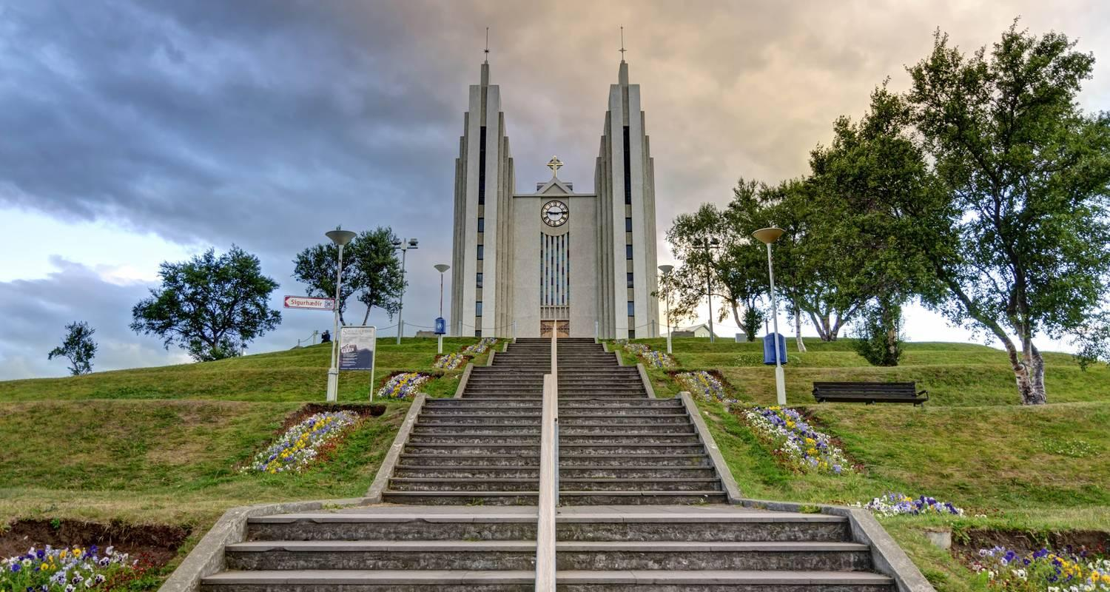

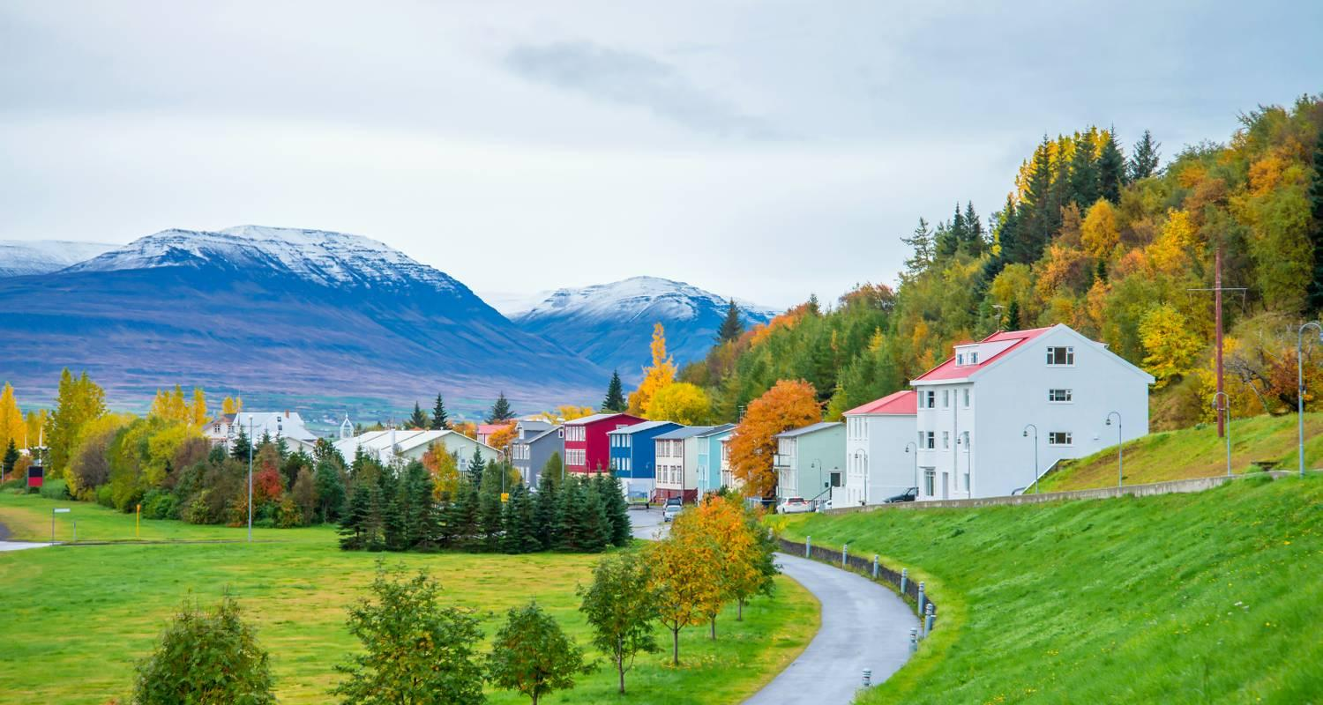

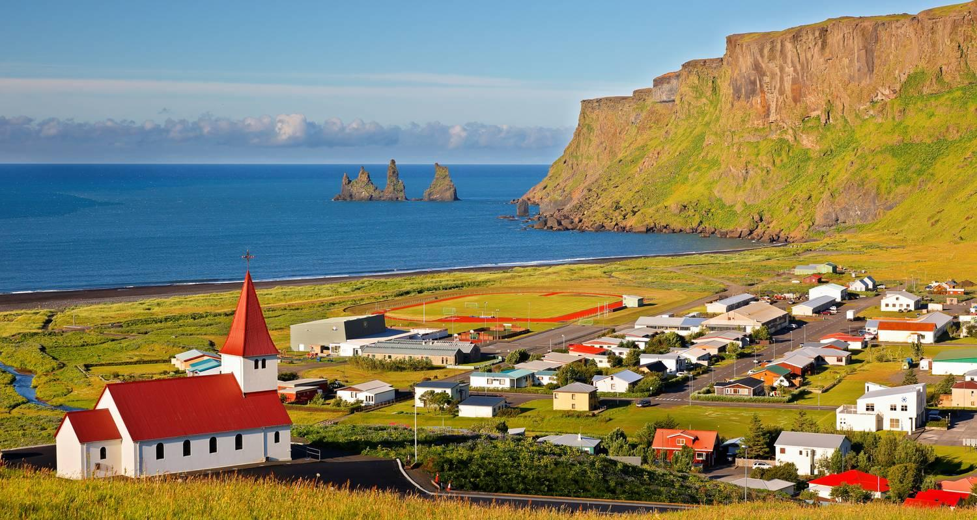

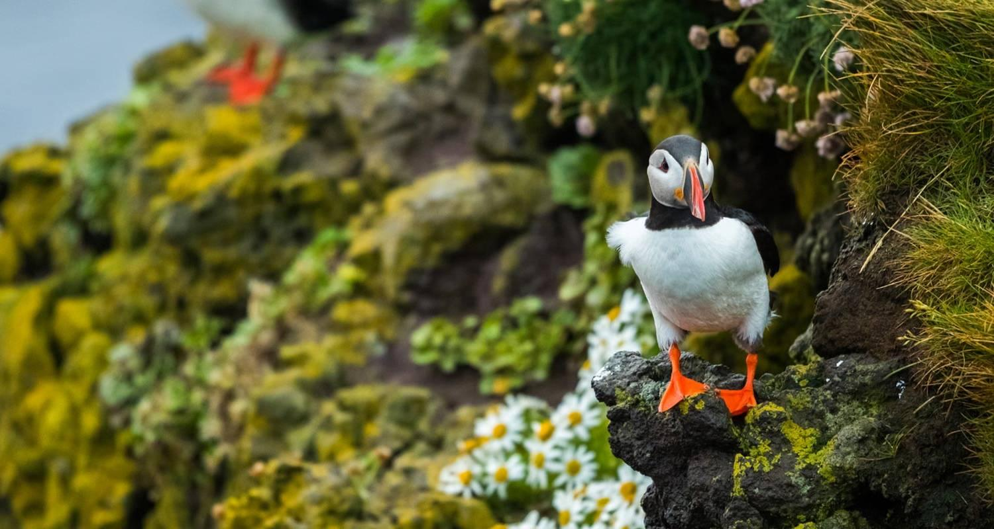

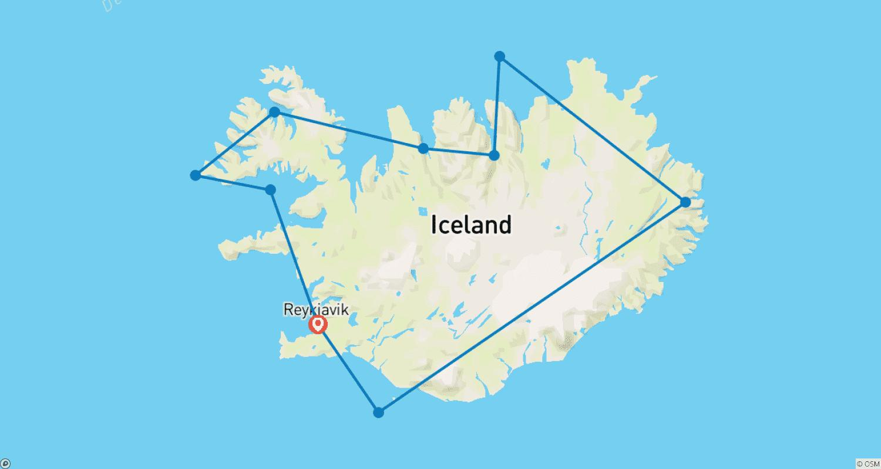

Tour ID: 247352  
Tour Name: Northern Legends: Ireland, Scotland & Iceland

Tour destinations: ['Dublin', 'Portrush', 'Oban', 'Portree', 'Isle of Skye', 'Stornoway', 'Isle of Lewis', 'Torshavn', 'Faroe Islands', 'Mykines Island', 'Seydisfjordur', 'Grimsey', 'Husavik', 'Reykjavik']

Tour destinations images:

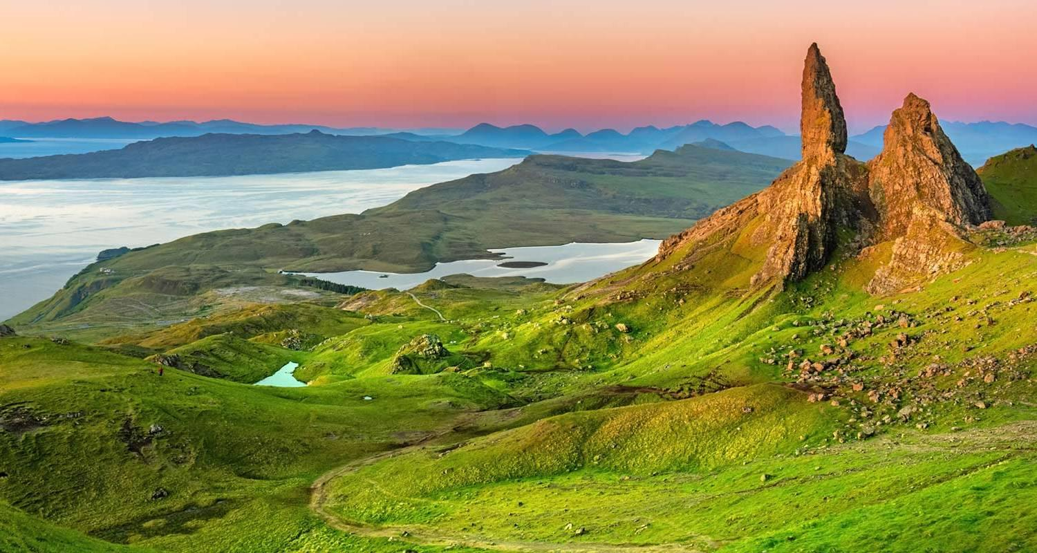

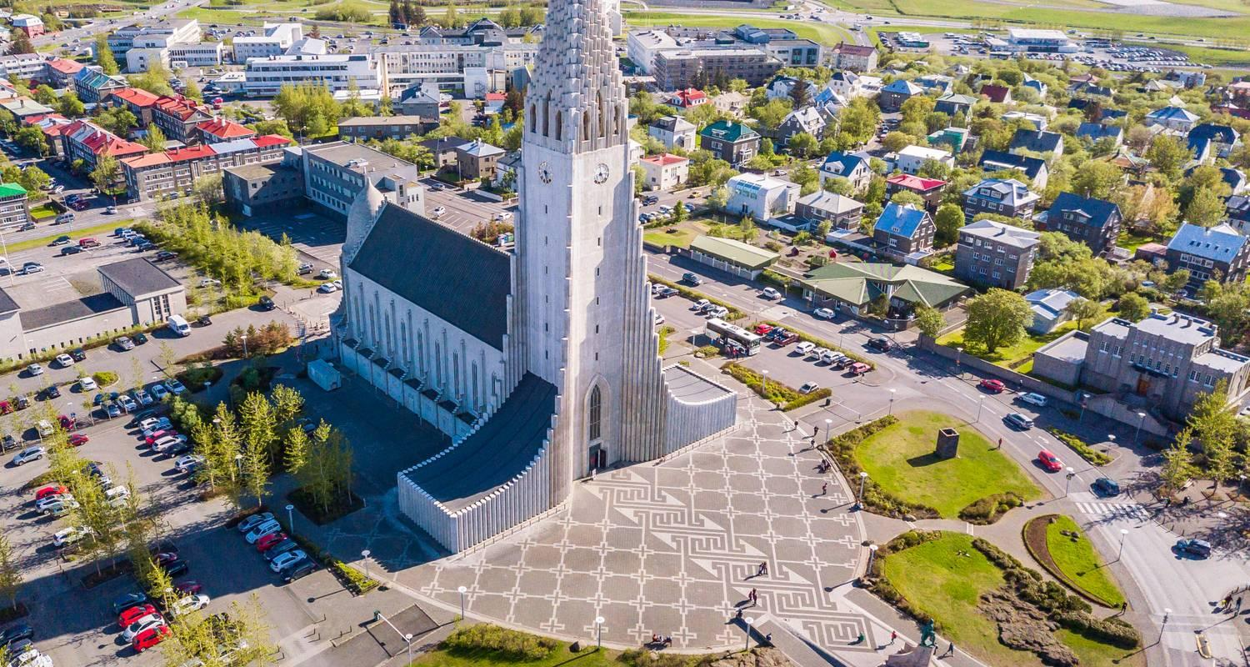

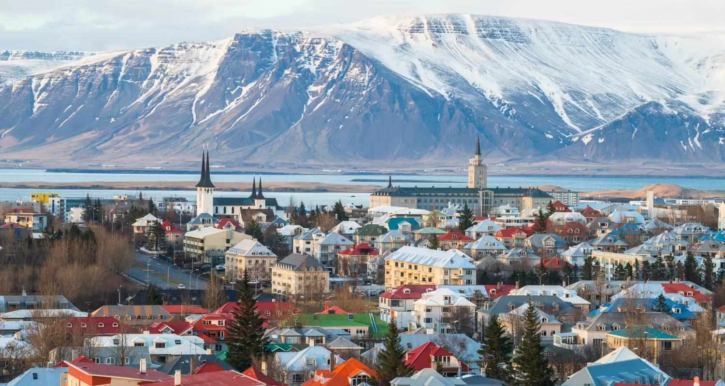

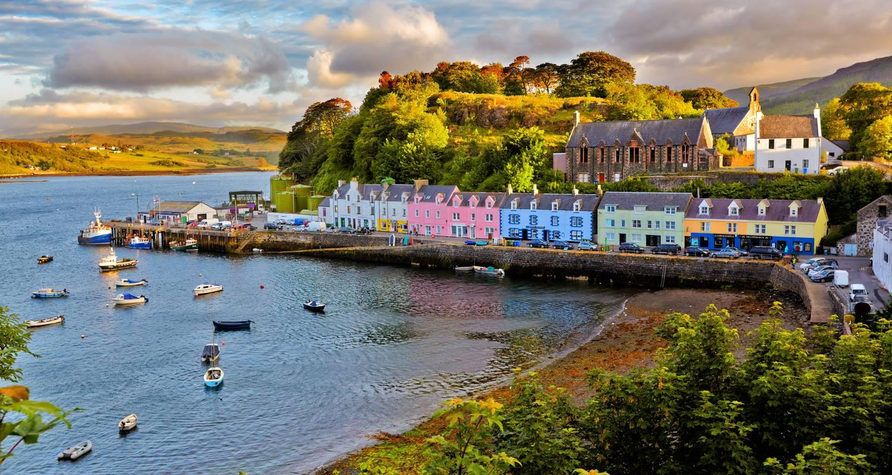

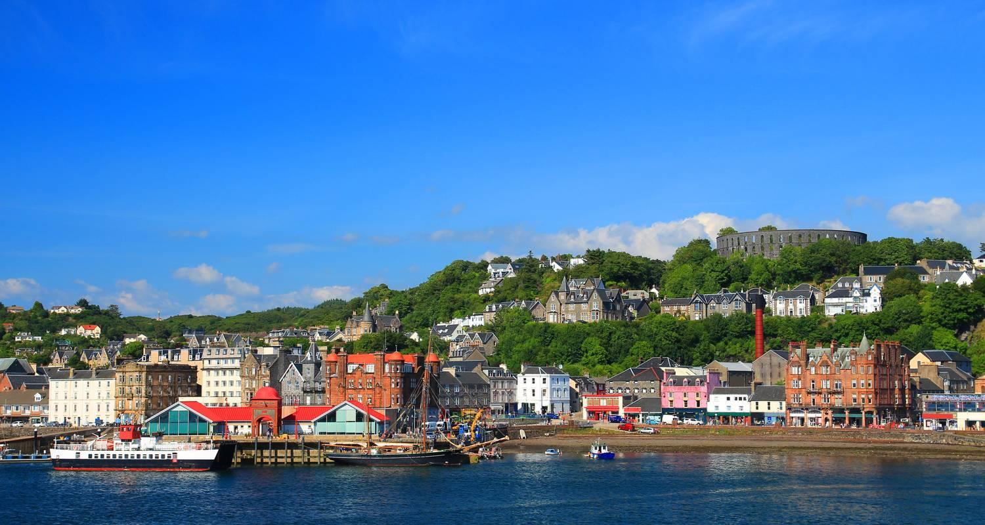

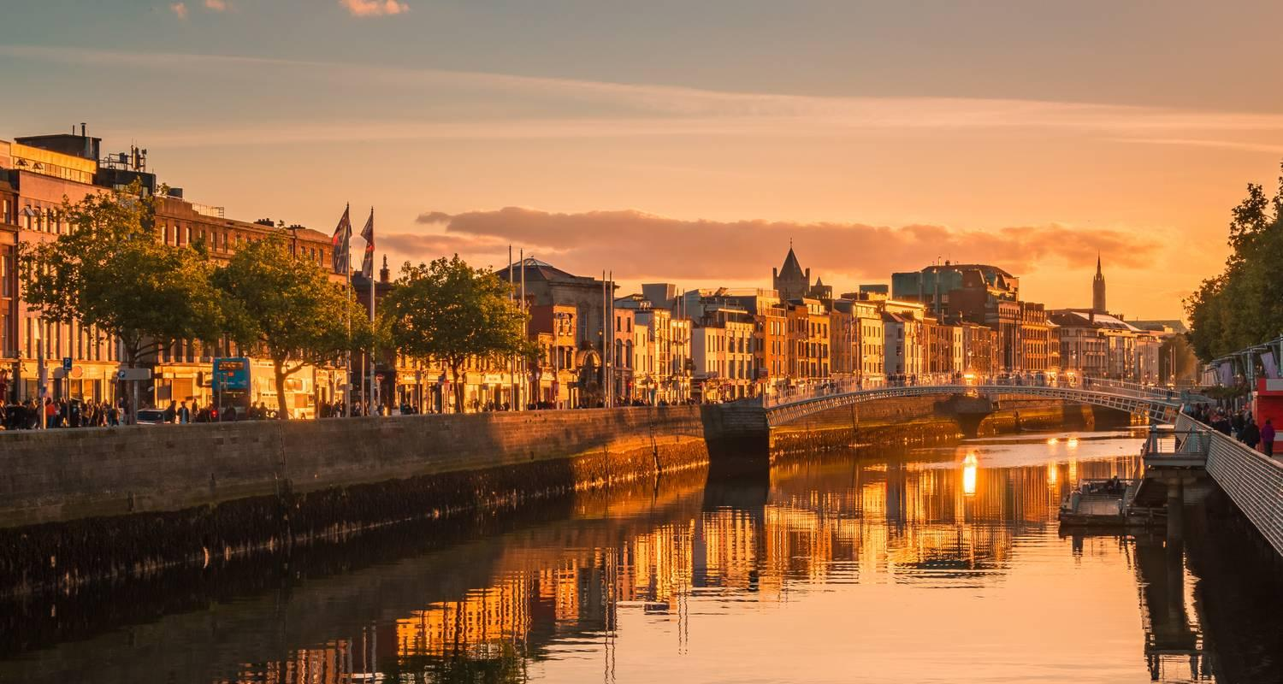

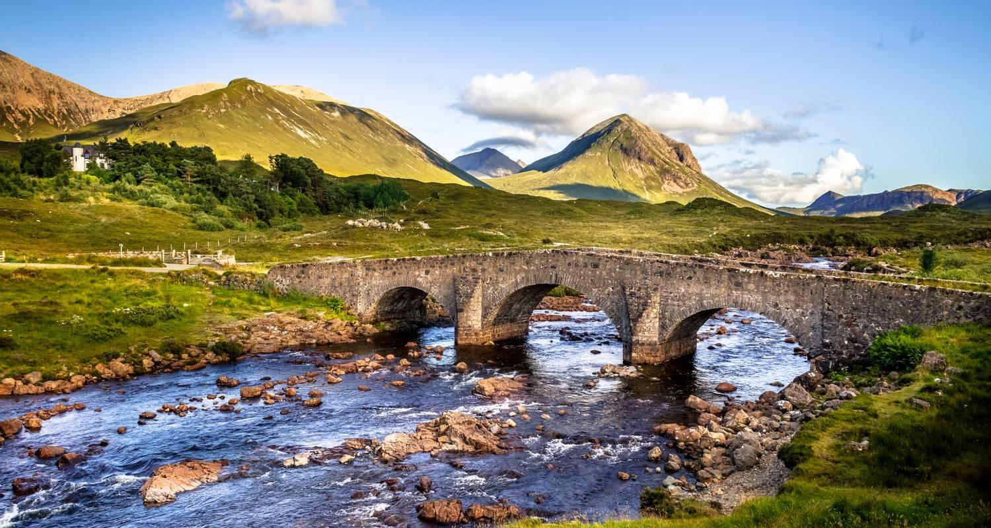

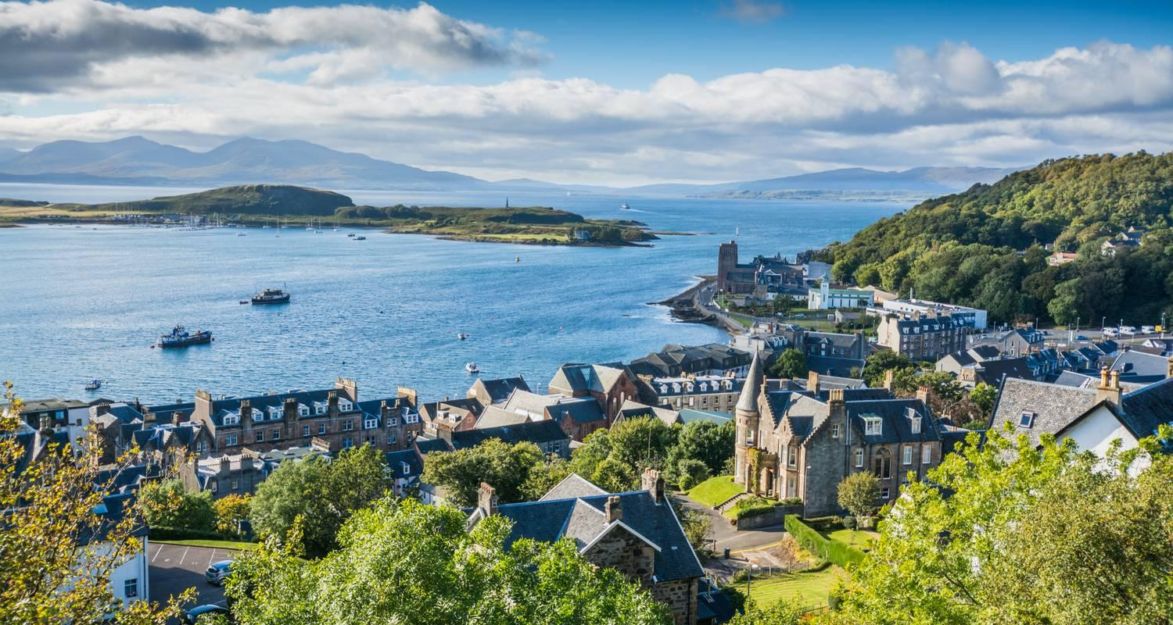

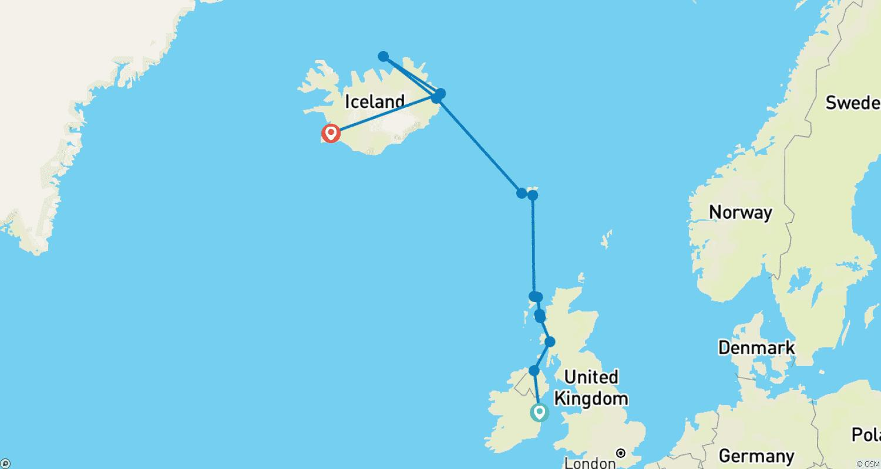

Tour ID: 247364  
Tour Name: Magical Iceland & Norwegian Fjords

Tour destinations: ['Reykjavik', 'Akureyri', 'Grimsey', 'Seydisfjordur', 'Torshavn', 'Lerwick', 'Fair Isle', 'Flam', 'Gudvangen', 'Bergen']

Tour destinations images:



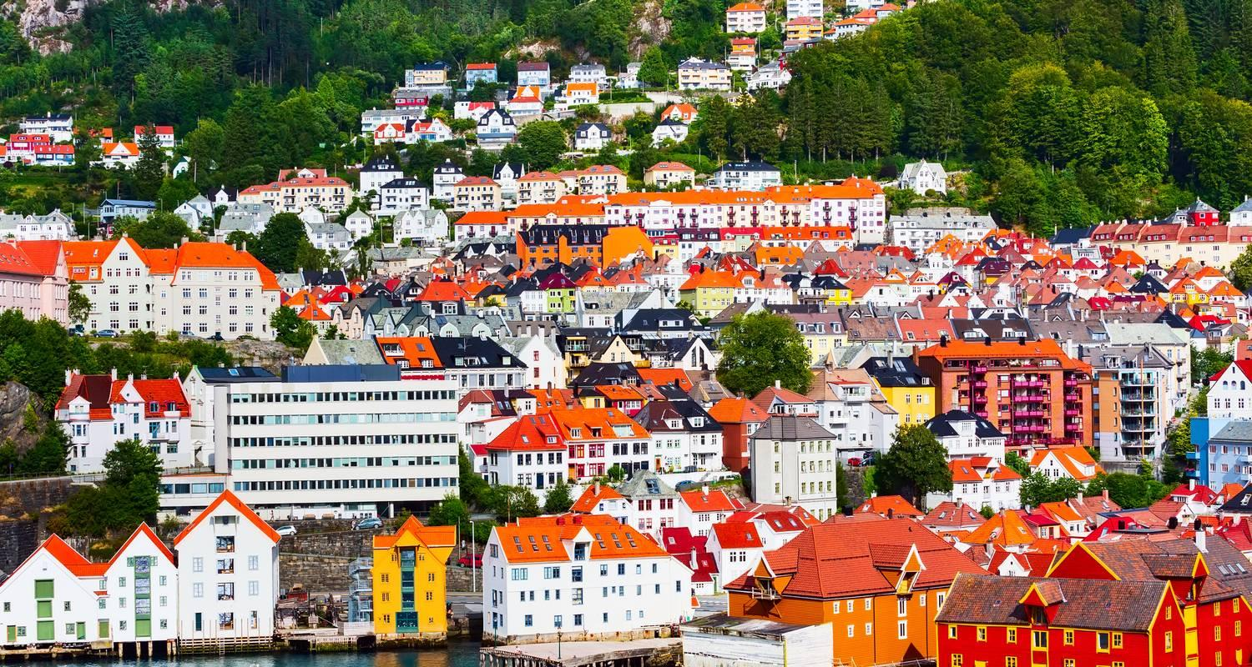

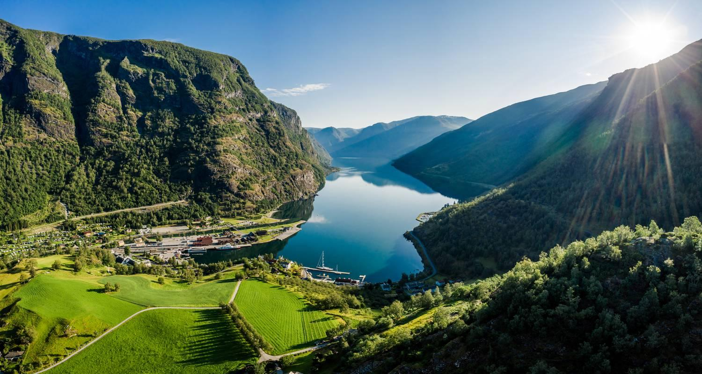





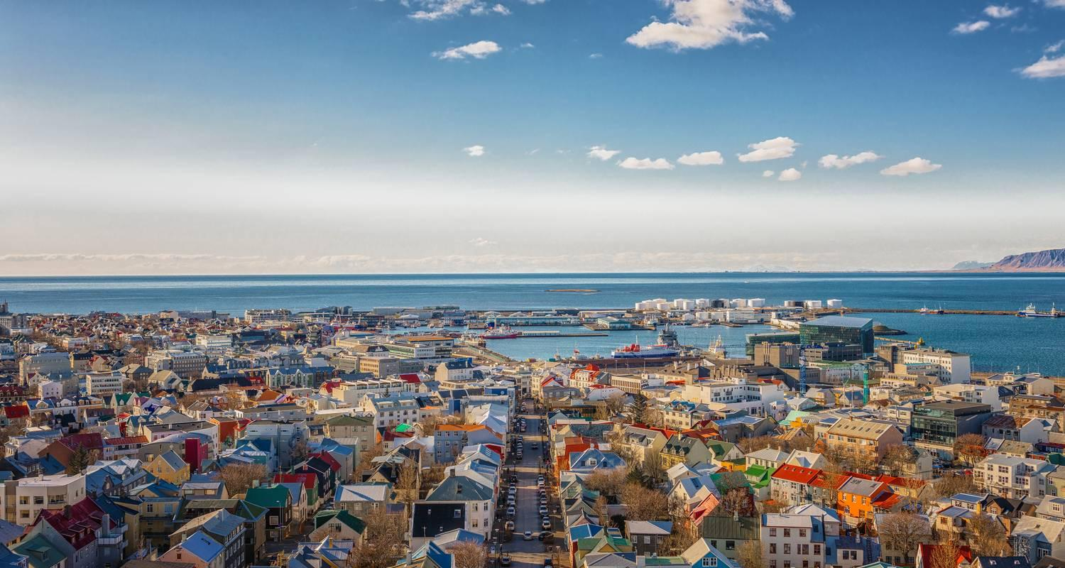

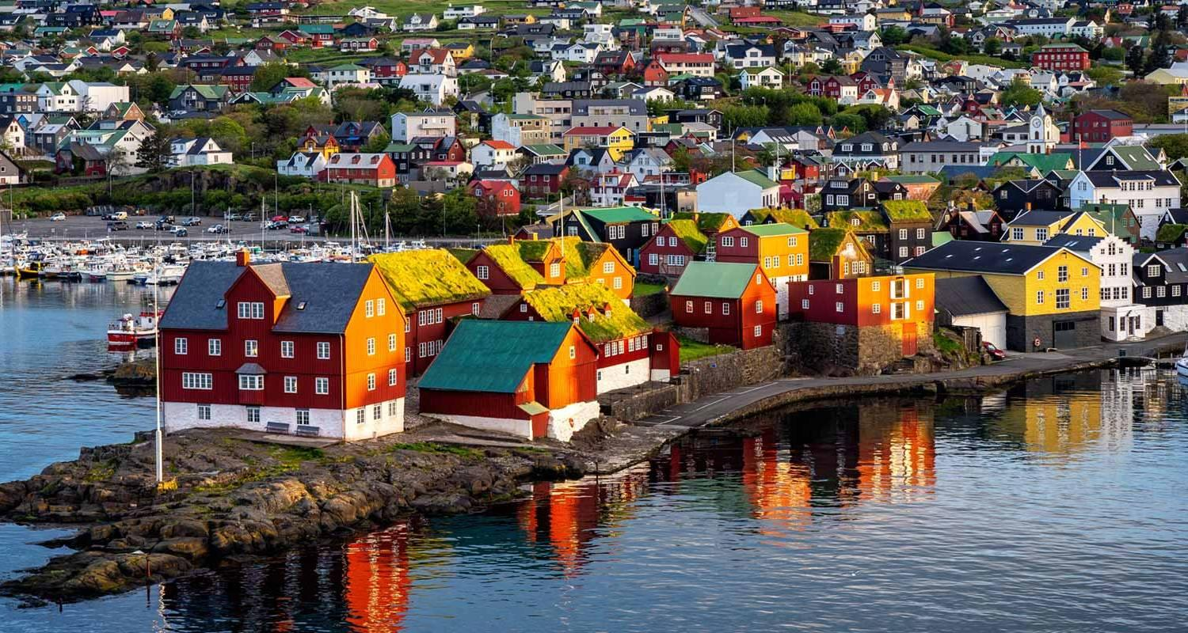

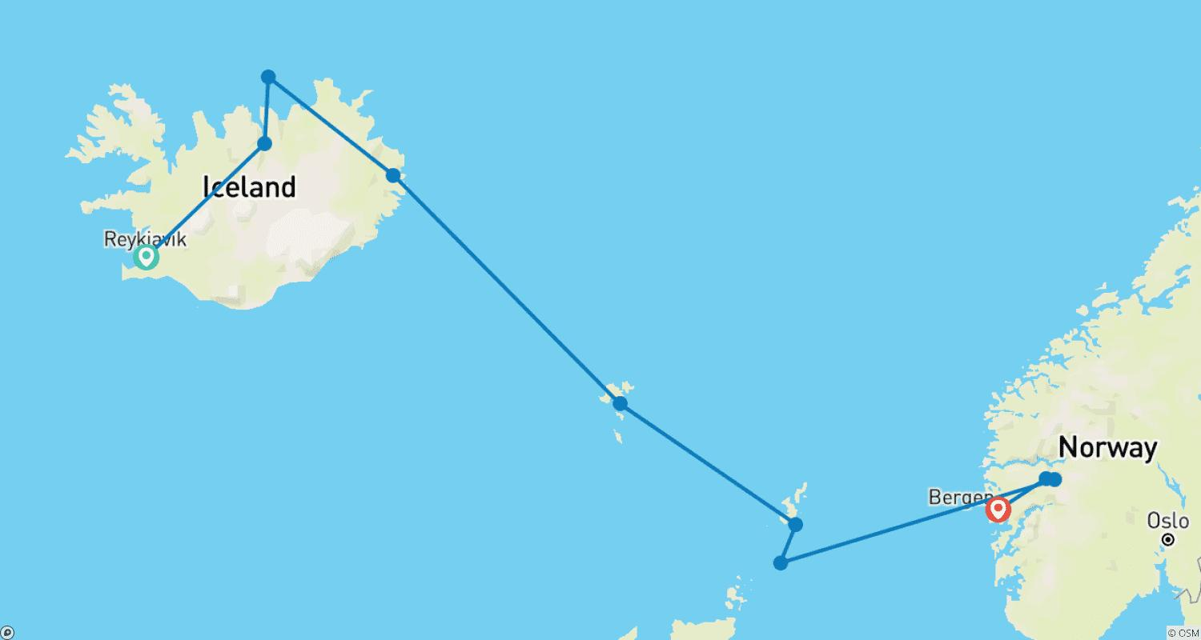

Tour ID: 247522  
Tour Name: Iceland Tour

Tour destinations: ['Reykjavik', 'Thingvellir National Park', 'Geysir', 'Gullfoss', 'Skogafoss', 'Reynisfjara', 'Vik', 'Blue Lagoon', 'Borgarfjörður', 'Hraunfossar', 'Grábrók Volcano', 'Keflavik']

Tour destinations images:





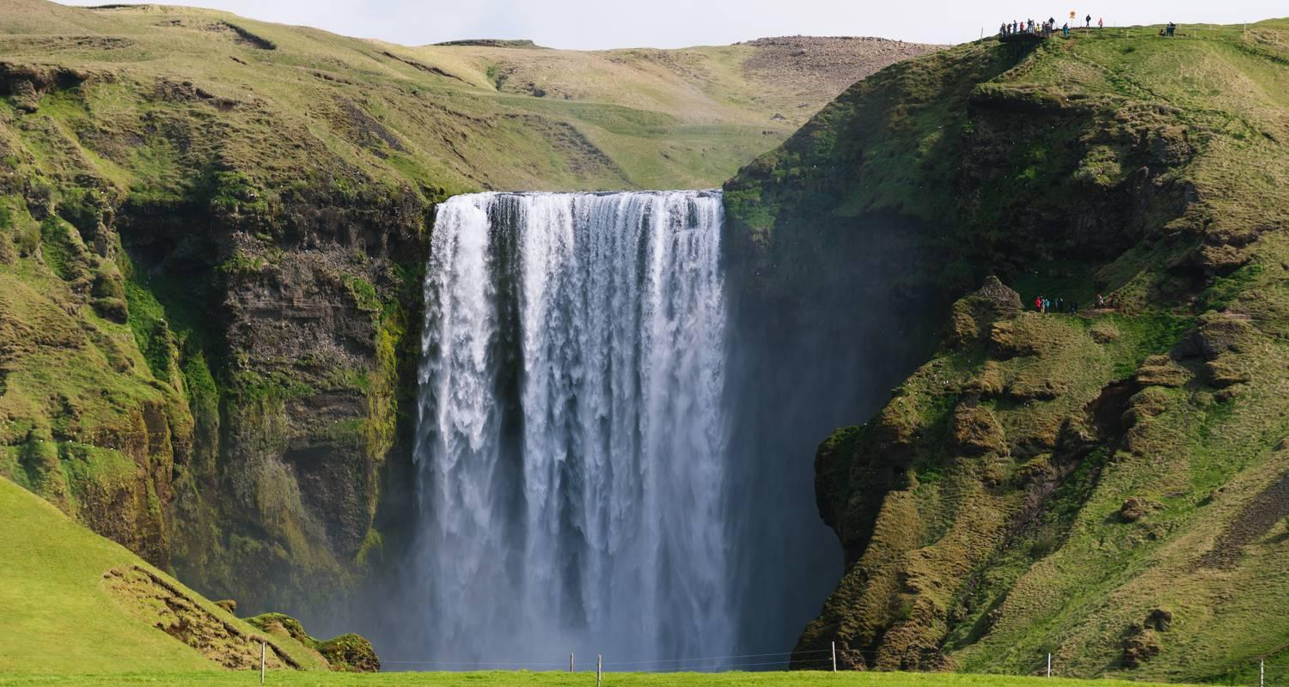

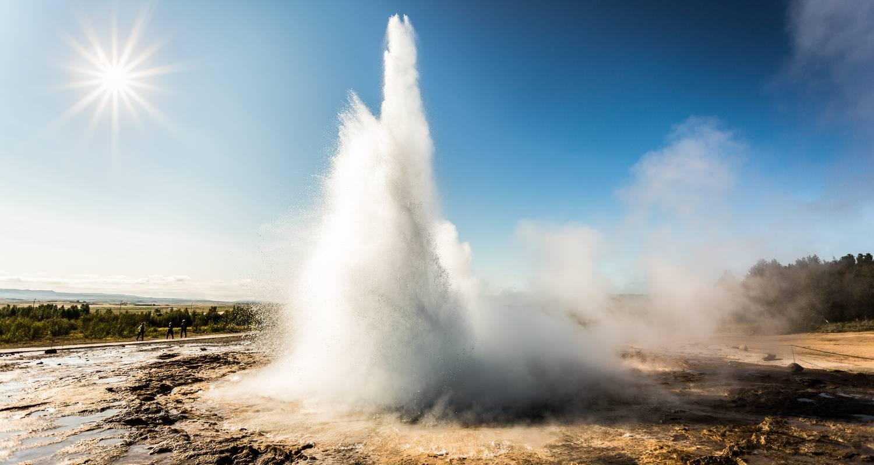

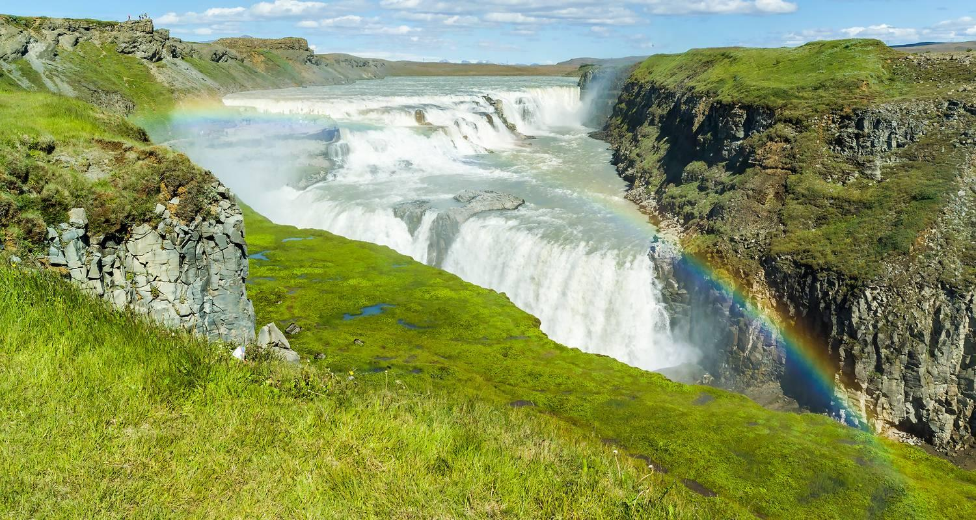

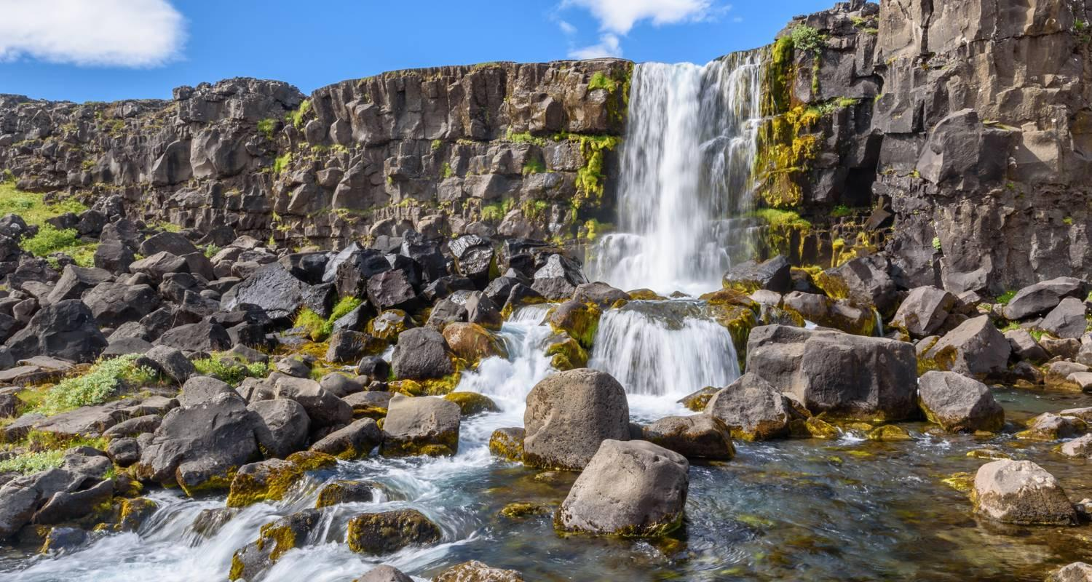

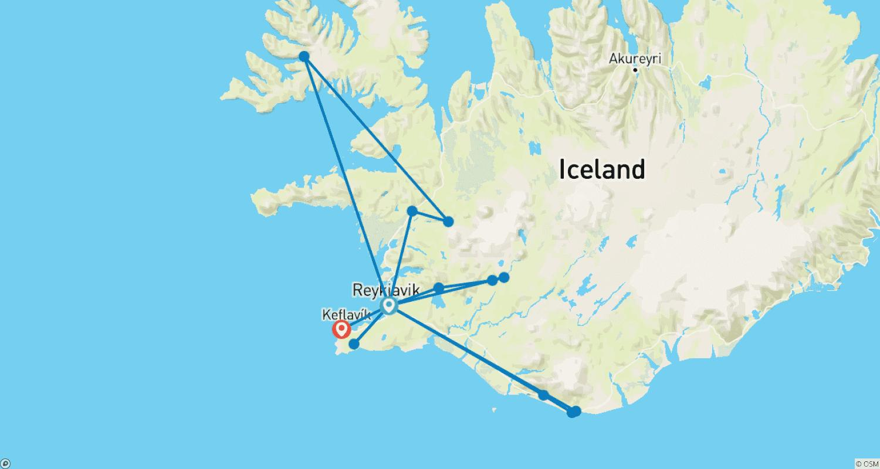

Tour ID: 248411  
Tour Name: Getaway to Iceland

Tour destinations: ['Reykjavik']

Tour destinations images:

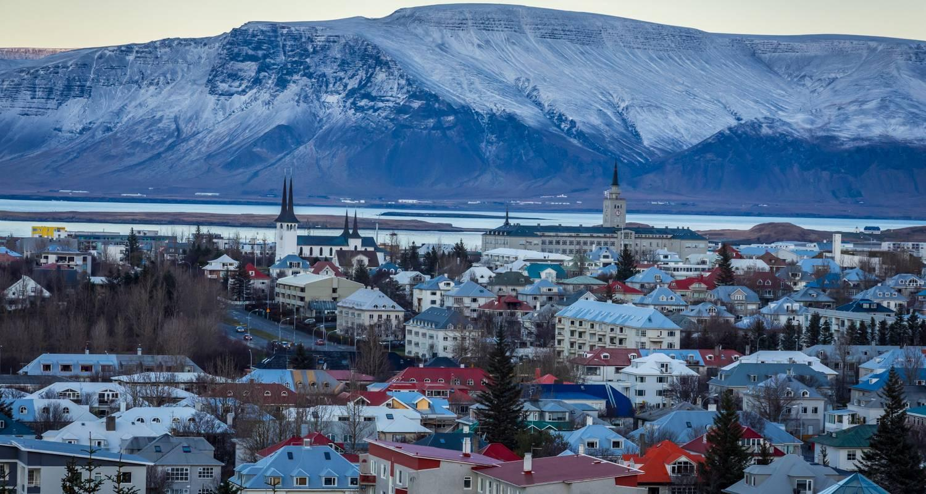

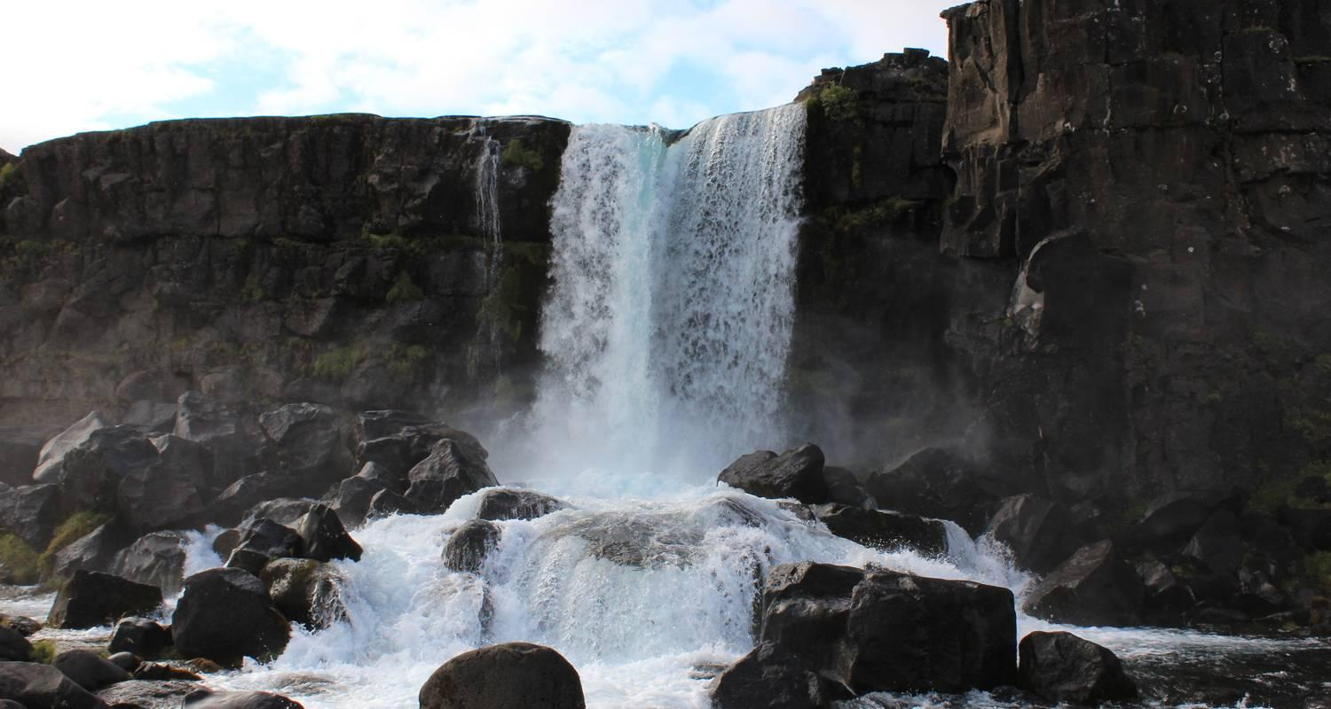



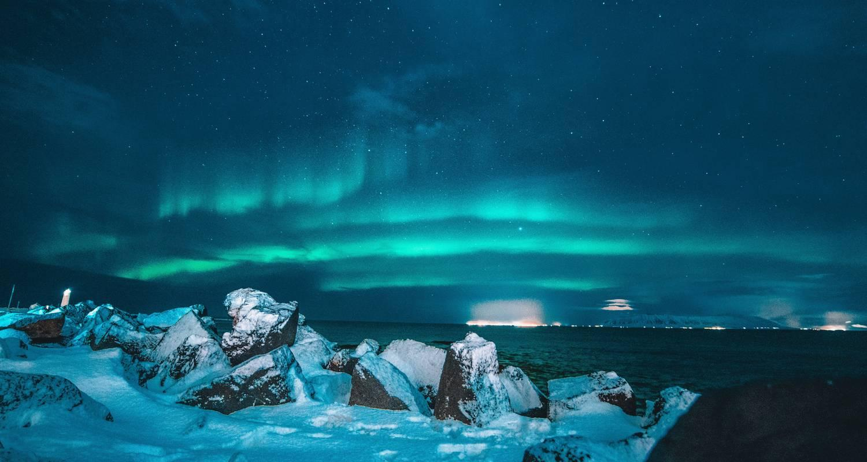

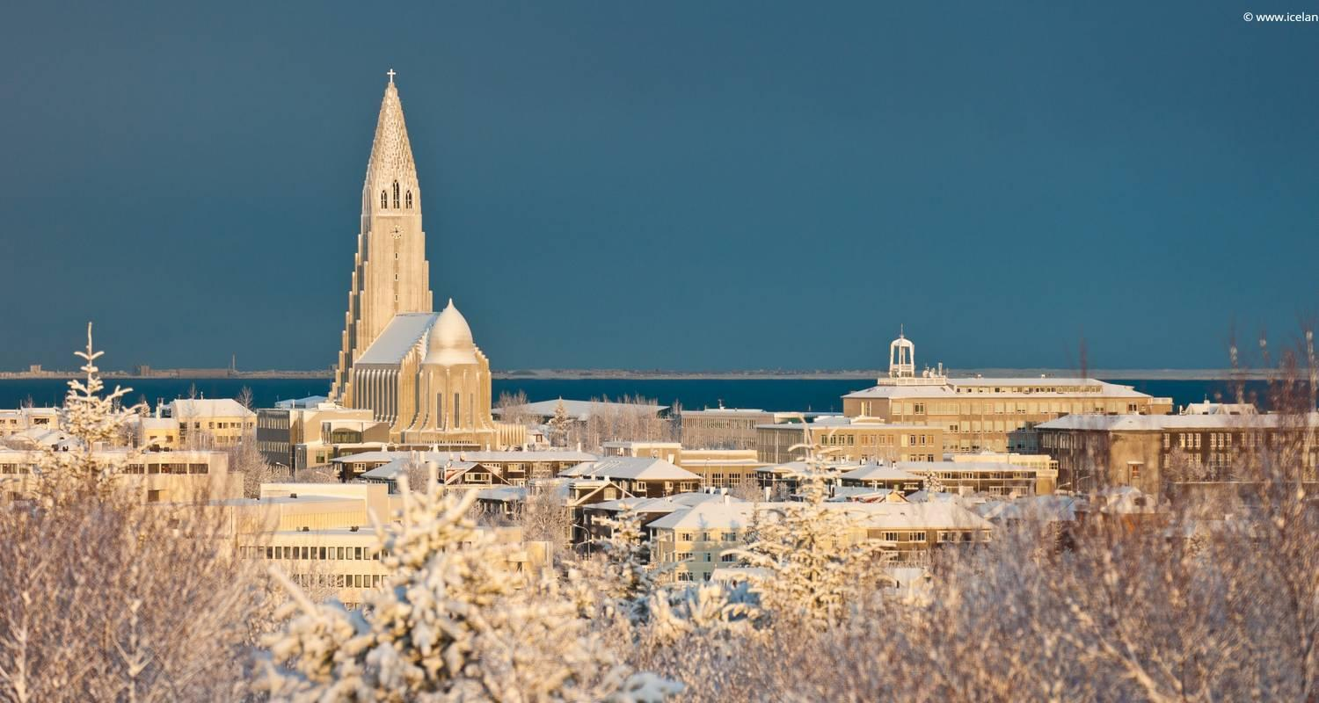

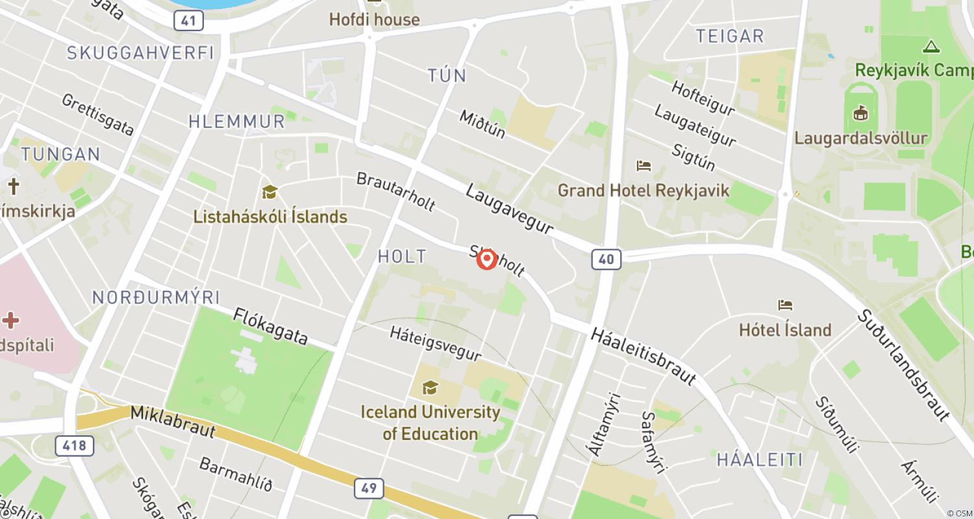

Tour ID: 249359  
Tour Name: With the Icebreaker to the North Pole

Tour destinations: ['Paris', 'Longyearbyen', 'Svalbard', 'Scoresby Sound', 'Reykjavik']

Tour destinations images:

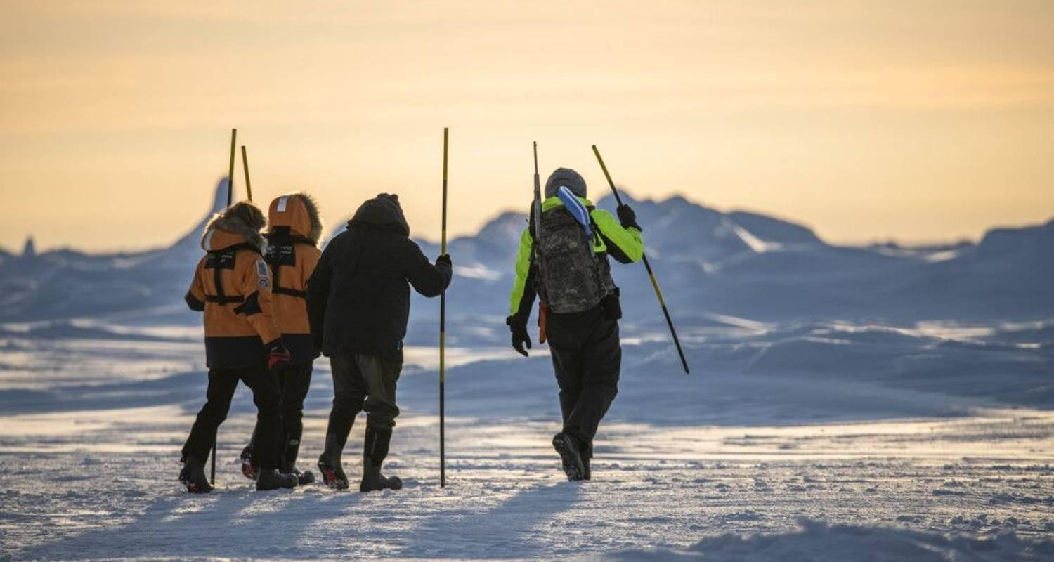

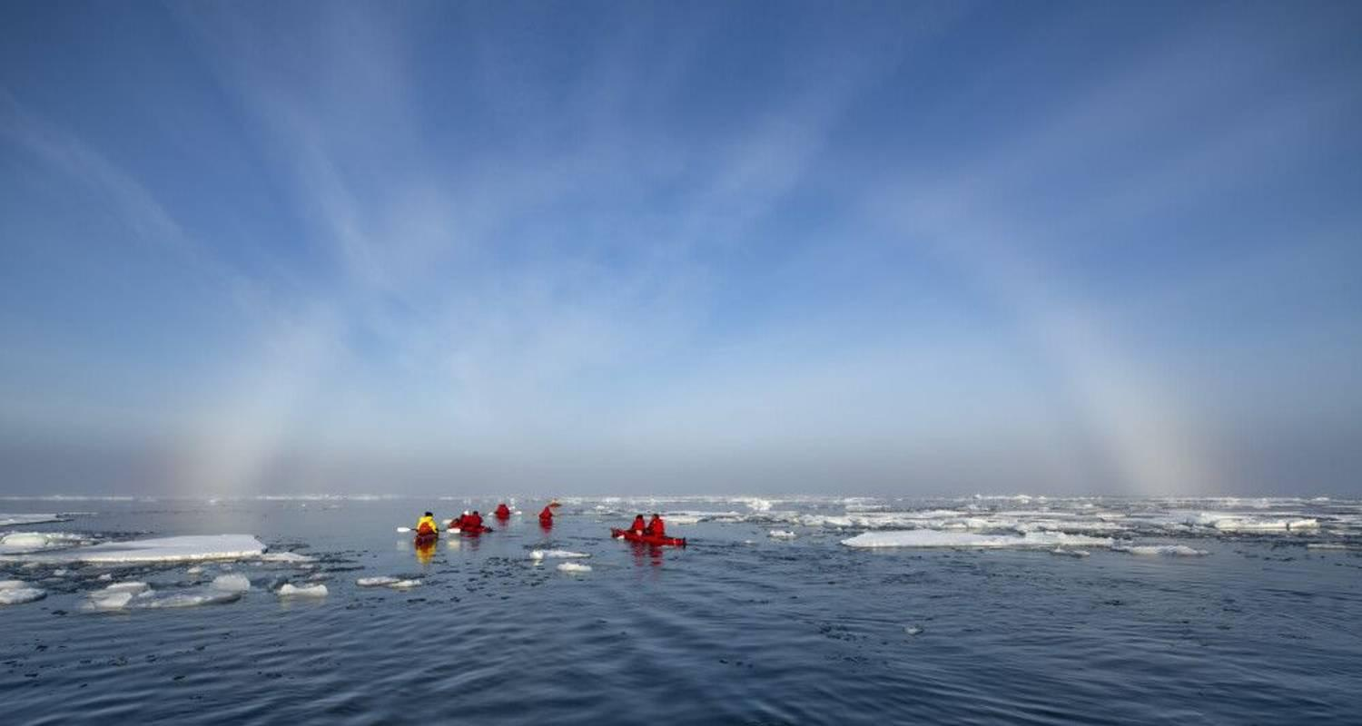

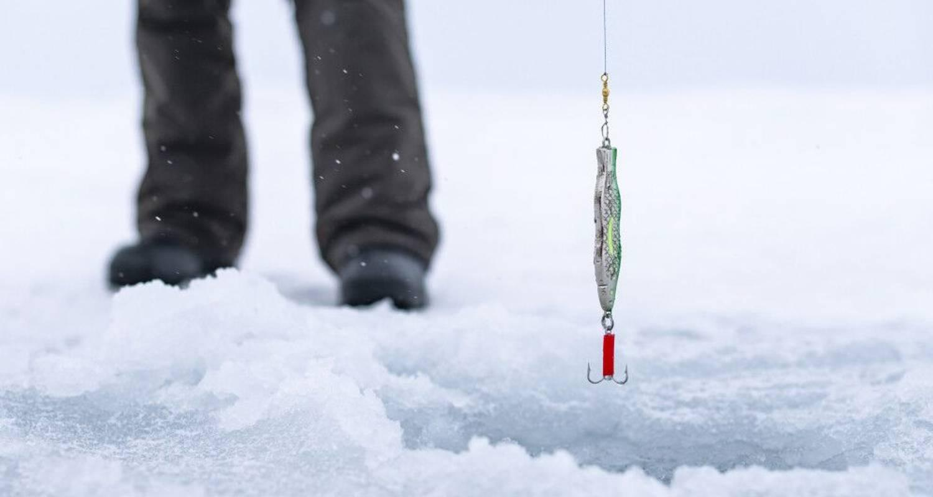

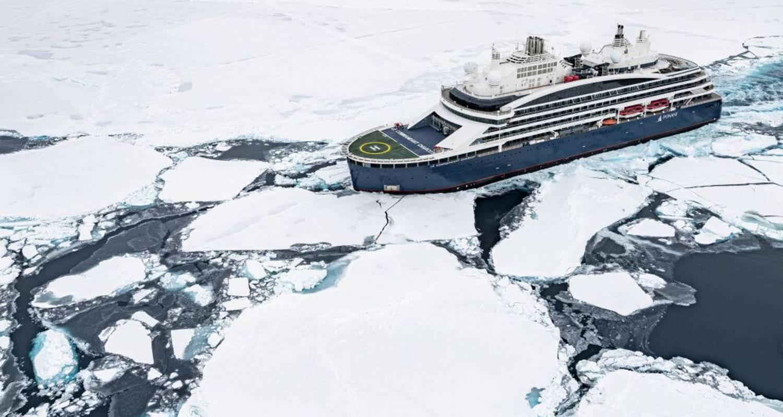



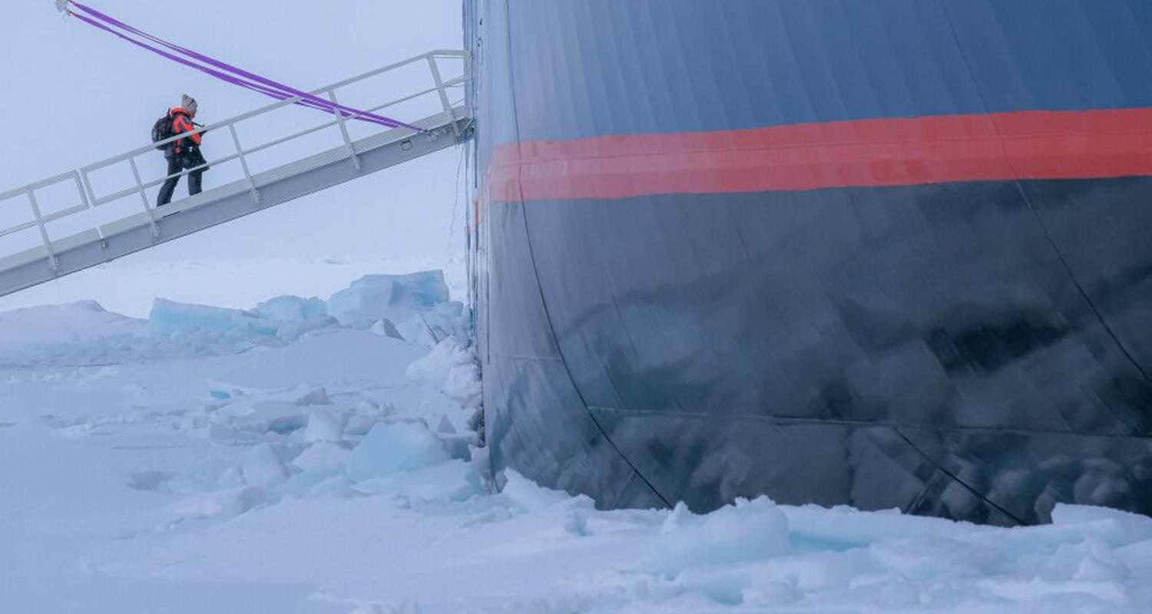

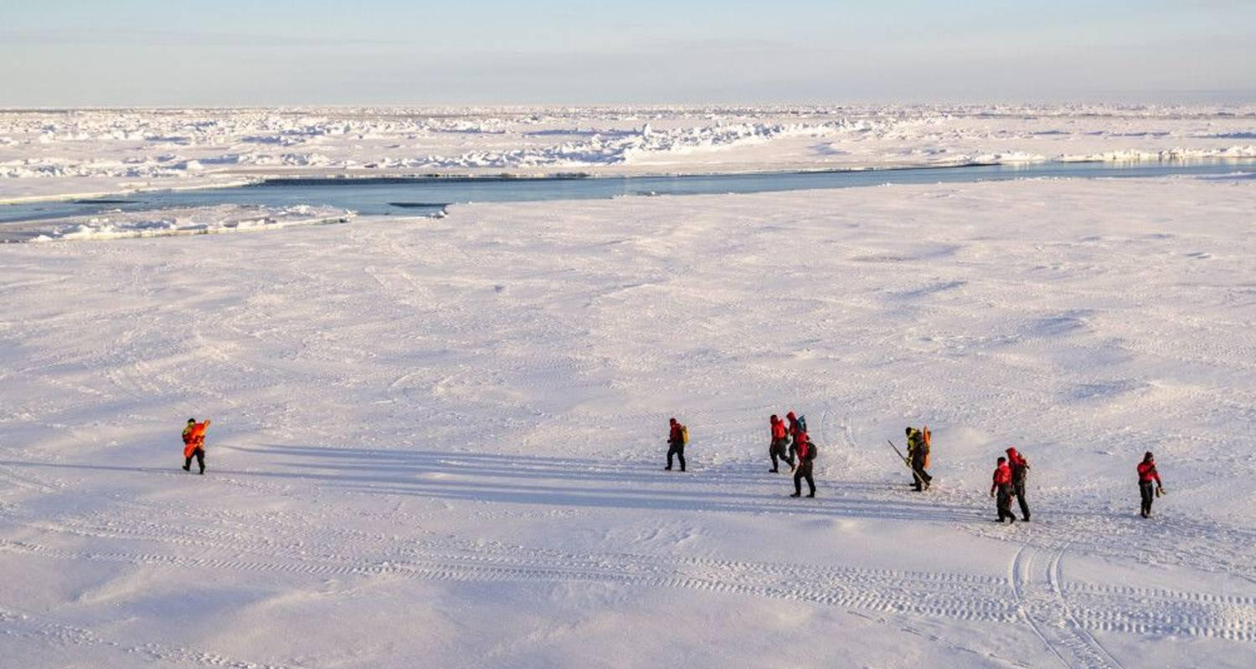

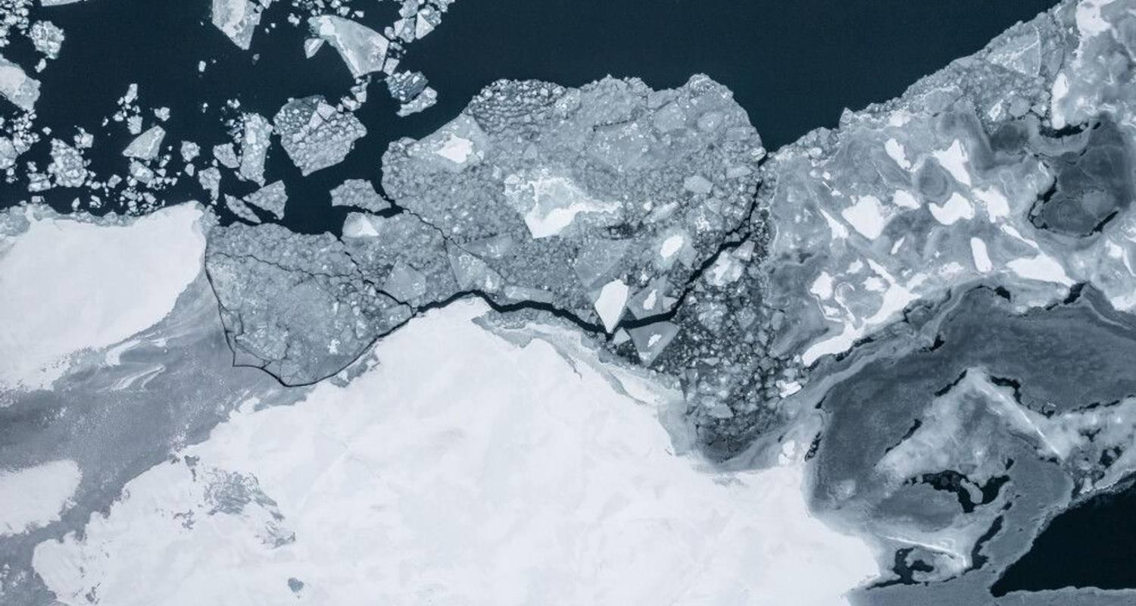

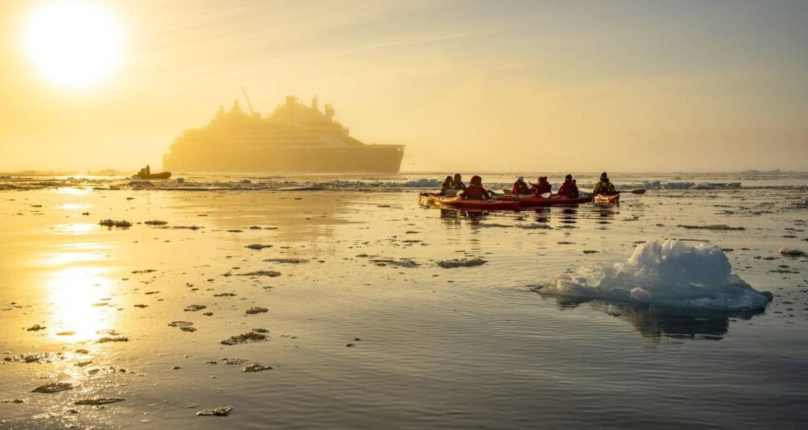

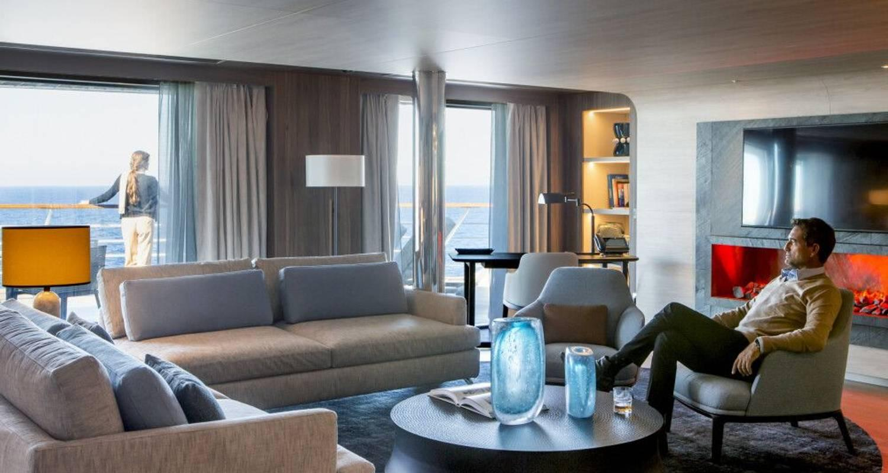

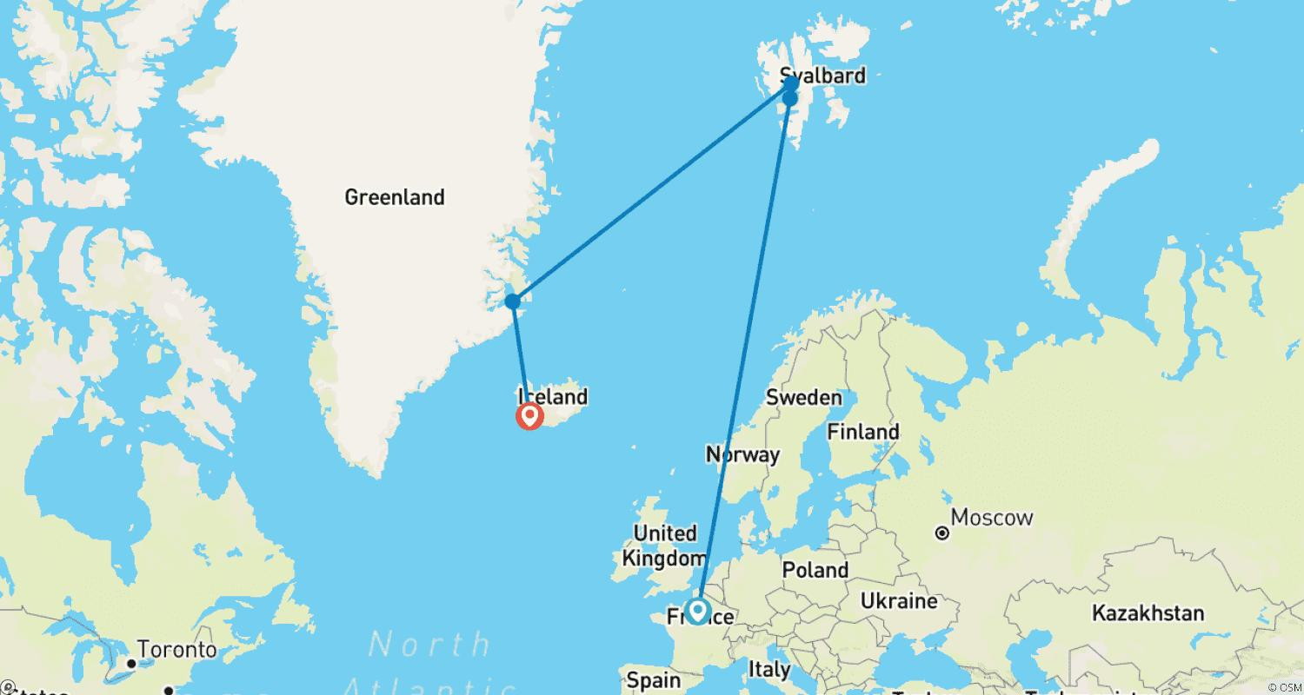

Tour ID: 249651  
Tour Name: Epic Glaciers

Tour destinations: ['Borgarnes', 'Kirkjufell Mountain', 'Arnarstapi', 'Thingvellir National Park', 'Vik', 'Reynisfjara', 'Skaftafell', 'Skogafoss', 'Reykjavik']

Tour destinations images:

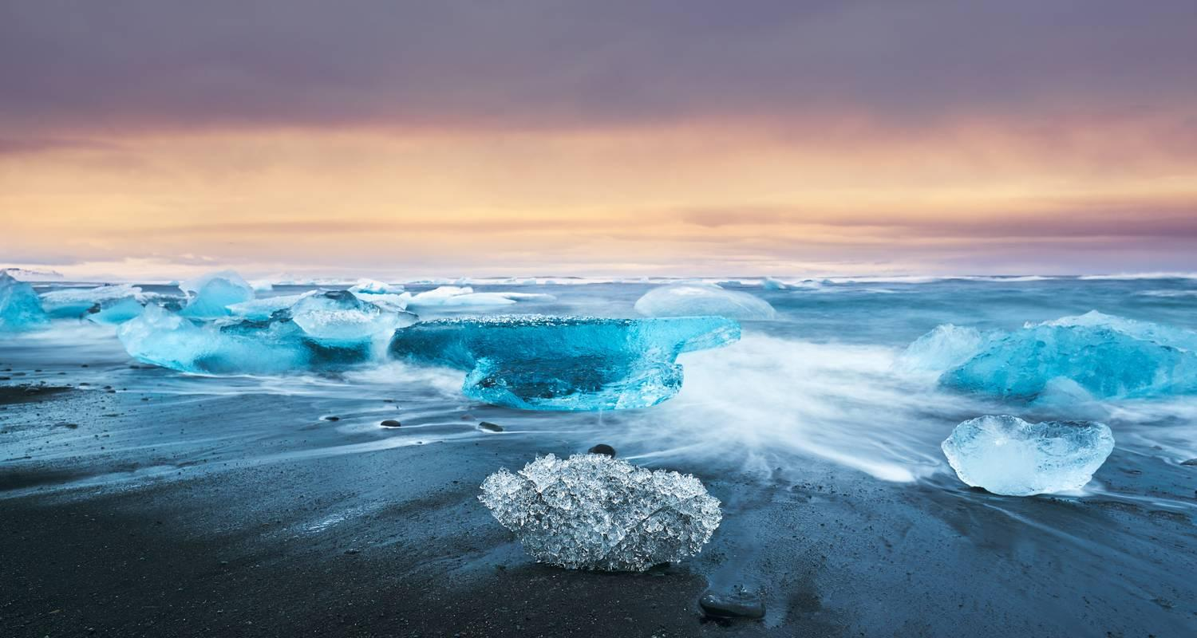

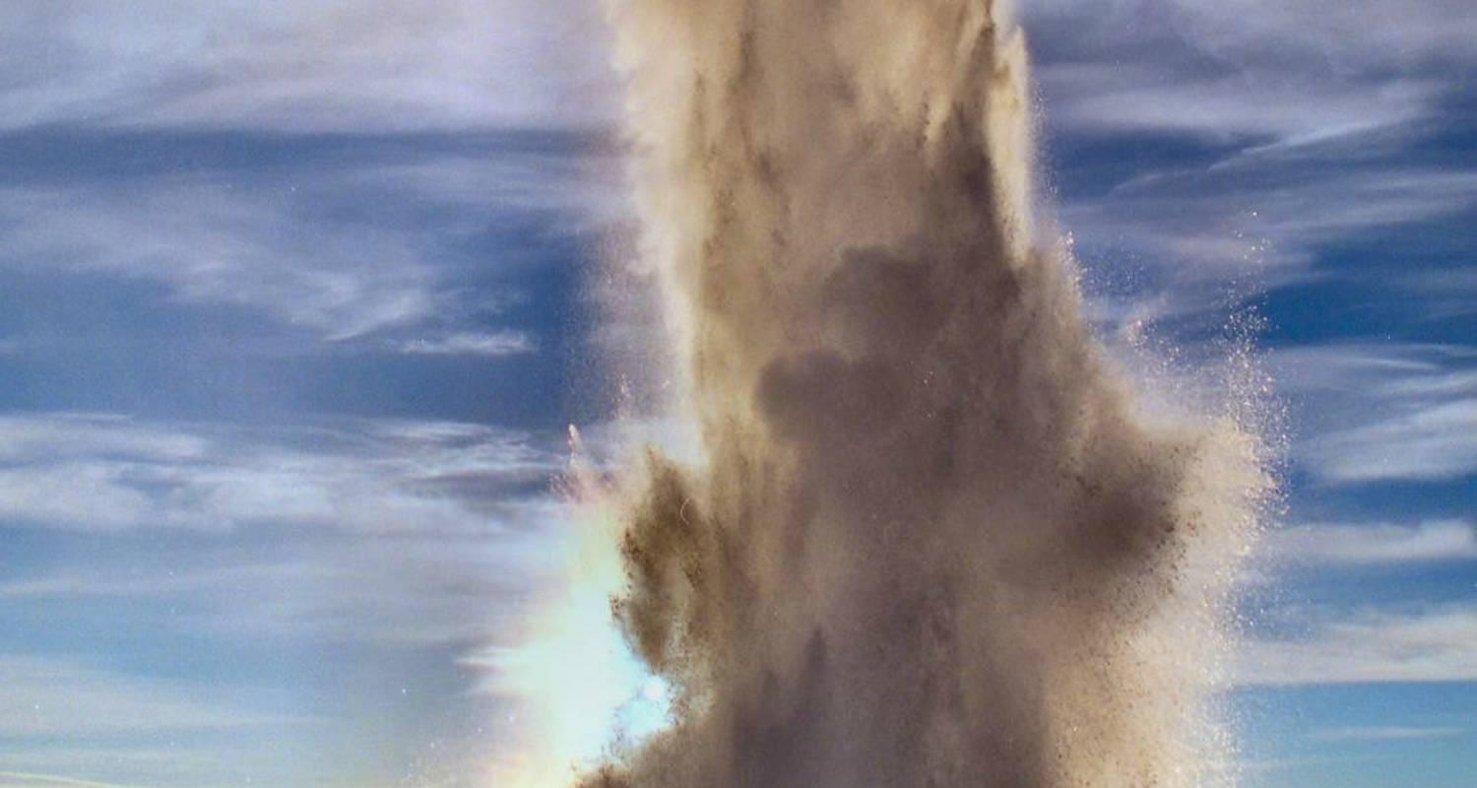

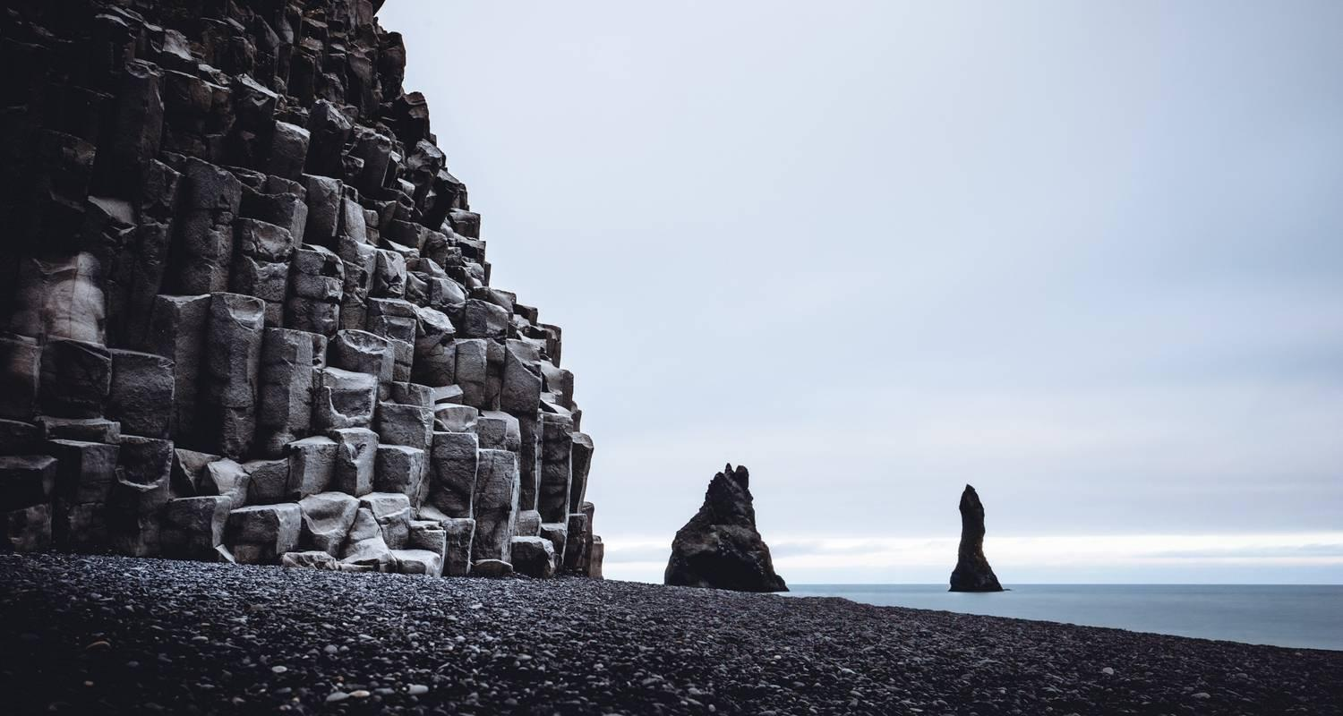



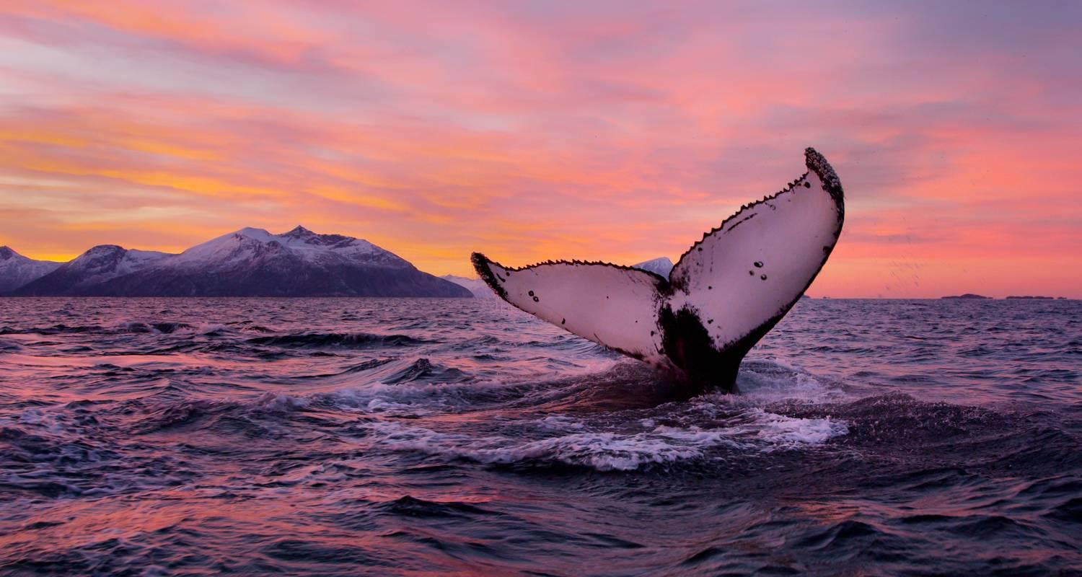

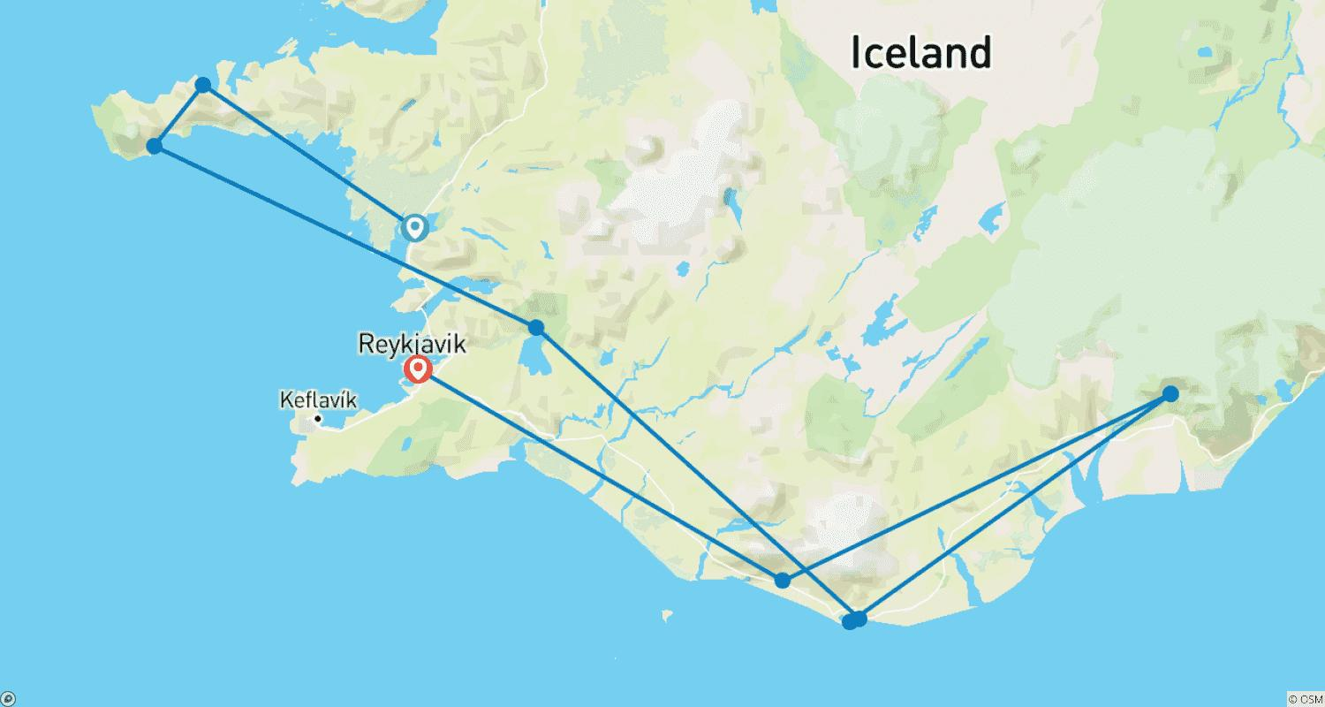

Tour ID: 249771  
Tour Name: Tastes of Norway & Iceland

Tour destinations: ['Tromso', 'Skarsvag', 'Harstad', 'Seydisfjordur', 'Grimsey', 'Husavik', 'Reykjavik']

Tour destinations images:

